ORACLE ADVANCED PRODUCT SERVICES

新希望六和
机房搬迁实施文档

ORACLE工程师： 蔡伟
报告生成日期: 2013-4-26

文档控制
此文档仅供新希望六和与山东瀚高科技内部审阅。
不得向与此无关的个人或机构传阅或复制

修改记录
日期 | 作者 | 修改记录
2013年5月27日 | 蔡伟 | 创建初始版本
审阅记录
审阅人 | 职位
母晓明 | 客户服务部经理
分发记录
审阅人 | 职位
常瑞东 | 公司副总

服务级别
客户名称 | 项目名称 | 严重等级 | 难度等级 | 受理时间 | 录入时间 | 客户要求时间
新希望六和 | 机房搬迁实施 | 等级2 | 等级2

响应时间 | 到场时间 | 完成时间 | 共计花费小时

目录

项目背景 5
实施过程 6
二、单节点rac安装 6
2.1检查目录空间 6
2.2检查内存 6
2.3检查系统包 6
2.4修改limits文件 7
2.5修改UDP、TCP内核参数 8
2.6修改AIO参数 8
2.7修改maxuproc参数 8
2.8调整虚拟内存参数 8
2.9修改网络参数 8
2.10停止NTP服务 9
2.11创建用户和组 9
2.12创建相关目录 10
2.13赋予用户权限 10
2.14修改用户密码 10
2.15修改用户环境变量 10
2.16检查PV 11
2.17修改磁盘属主 12
2.18修改磁盘权限 12
2.19修改磁盘reverse policy属性 13
2.20查看磁盘属性修改结果 13
2.21检查磁盘磁盘内容 13
2.22安装grid软件 13
2.23安装database软件 31
三、单节点rac升级psu 36
3.1下载最新OPatch 36
3.2检查补丁冲突 37
3.3正式打PSU 38
四、创建测试库 40
4.1NFS目录创建 40
4.2备份主库 41
4.3在备库进行restore 45
五、正式实施--dataguard搭建 51
5.1设置主库force logging 51
5.2修改主库（rac端）参数 51
5.3为备端创建修改pfile 52
5.4修改主库tnsnames.ora 53
5.5修改hosts文件 54
5.6备份数据库 54
5.7备份for standby控制文件 55
5.8复制密码文件 55
5.9恢复备库 55
5.10备端创建spfile 59
5.11启动备库添加standbyredo日志 60
5.12监视DG运行状态 60
5.13切换2号节点服务 62
六、备端添加节点 63
6.1检查目录空间 63
6.2检查内存 63
6.3检查系统包 63
6.4修改hosts文件 63
6.5修改limits文件 64
6.6修改UDP、TCP内核参数 64
6.7修改AIO参数 64
6.8修改maxuproc参数 64
6.9调整虚拟内存参数 65
6.10修改网络参数 65
6.11停止NTP服务 66
6.12创建用户和组 66
6.13创建相关目录 66
6.15修改磁盘属主 67
6.16查看磁盘属性 69
6.17配置ssh等效性 70
6.18创建oraIventory目录 70
6.19备端添加节点 70
七、主备切换 72
7.1主端切换为备端 72
7.2备端切为主端 73
7.3添加temp文件 73
7.4修改新节点参数 74
7.5添加db资源 75
八、添加3号节点 75
8.1检查目录空间 75
8.2检查内存 76
8.3检查系统包 76
8.4 修改hosts文件 76
8.5修改limits文件 77
8.6 修改UDP、TCP参数 77
8.7修改AIO参数 77
8.8修改maxuproc参数 77
8.9调整虚拟内存参数 77
8.10修改网络参数 78
8.11停止NTP服务 78
8.12创建用户和组 79
8.13创建相关目录 79
8.14修改环境变量 79
8.15修改磁盘属主 80
8.16查看磁盘属性 82
8.17配置SSH等效性 82
8.18创建oraIventory目录 83
8.19添加第三节点 83
8.20 添加easdb3实例 85
8.21修改easdb3参数 87
8.22删除eas2服务 88
8.23修改db_unique_name 88
8.24添加oradb资源 88
8.25删除standby资源所包含的实例 88
8.26添加instance easdb1、easdb2到oradb资源 88
8.27添加服务 88
8.28集群状态 89
九、EM管理器创建 90
三、实施问题及解决办法 91
1、归档无法删除问题 91
2、清除DG配置后重启实例无法启动问题 93

项目背景
新希望六和集团由于机房搬迁，需要将数据库服务器平稳安全的过渡至电信机房，软硬件环境及实施方案如下：
主端服务器：IBM P740（oracle11.2.0.3 rac）
电信机房端服务器：IBM p570（oracle11.2.0.3 单节点rac）
数据量：1.3TB
实施方案：配置主端rac至备端单节点rac的Dataguard环境，拆除主端2号节点添加至备端，进行主备切换，测试应用正常之后拆除原主端1号节点添加至新主端rac集群，最终形成3节点集群rac环境。整个过程能保证任意时刻两台服务器在线，确保了应用的高可用性以及数据的安全性。

实施过程

二、单节点rac安装

2.1检查目录空间
# df -g
Filesystem GB blocks Free %Used Iused %Iused Mounted on
/dev/hd4 30.00 29.76 1% 11084 1% /
/dev/hd2 5.00 2.99 41% 47814 7% /usr
/dev/hd9var 5.00 4.92 2% 3036 1% /var
/dev/hd3 10.00 3.64 64% 2015 1% /tmp
/dev/hd1 5.00 5.00 1% 5 1% /home
/dev/hd11admin 0.12 0.12 1% 5 1% /admin
/proc - - - - - /proc
/dev/hd10opt 0.12 0.04 69% 2264 20% /opt

2.2检查内存
# /usr/sbin/lsattr -E -l sys0 -a realmem
realmem 73859072 Amount of usable physical memory in Kbytes False
# prtconf
Memory Size: 72128 MB
Good Memory Size: 72128 MB
Paging Space Information
Total Paging Space: 32768MB
Percent Used: 1%

2.3检查系统包
#lslpp –l bos.adt.base bos.adt.lib bos.adt.libm bos.perf.libperfstat bos.perf.perfstat bos.perf.proctools rsct.basic.rte rsct.compat.clients.rte xlC.aix61.rte xlC.rte

Fileset Level State Description
----------------------------------------------------------------------------
Path: /usr/lib/objrepos
bos.adt.base 6.1.7.16 COMMITTED Base Application Development
Toolkit
bos.adt.lib 6.1.2.0 COMMITTED Base Application Development
Libraries
bos.adt.libm 6.1.7.16 COMMITTED Base Application Development
Math Library
bos.perf.libperfstat 6.1.7.17 COMMITTED Performance Statistics Library
Interface
bos.perf.perfstat 6.1.7.17 COMMITTED Performance Statistics
Interface
bos.perf.proctools 6.1.7.16 COMMITTED Proc Filesystem Tools
rsct.basic.rte 3.1.2.1 COMMITTED RSCT Basic Function
rsct.compat.clients.rte 3.1.2.0 COMMITTED RSCT Event Management Client
Function
xlC.aix61.rte 11.1.0.2 COMMITTED XL C/C++ Runtime for AIX 6.1
xlC.rte 11.1.0.2 COMMITTED XL C/C++ Runtime

Path: /etc/objrepos
bos.adt.base 6.1.7.16 COMMITTED Base Application Development
Toolkit
bos.perf.libperfstat 6.1.7.17 COMMITTED Performance Statistics Library
Interface
bos.perf.perfstat 6.1.1.0 COMMITTED Performance Statistics
Interface
rsct.basic.rte 3.1.2.1 COMMITTED RSCT Basic Function

2.4修改limits文件
Vi /etc/security/limits

default:
fsize = -1
core = 2097151
cpu = -1
data = -1
rss = -1
stack = -1
nofiles = -1

2.5修改UDP、TCP内核参数
# /usr/sbin/no -p -o tcp_ephemeral_low=9000 -o tcp_ephemeral_high=65500
Setting tcp_ephemeral_low to 9000
Setting tcp_ephemeral_low to 9000 in nextboot file
Setting tcp_ephemeral_high to 65500
Setting tcp_ephemeral_high to 65500 in nextboot file
# /usr/sbin/no -p -o udp_ephemeral_low=9000 -o udp_ephemeral_high=65500
Setting udp_ephemeral_low to 9000
Setting udp_ephemeral_low to 9000 in nextboot file
Setting udp_ephemeral_high to 65500
Setting udp_ephemeral_high to 65500 in nextboot file

2.6修改AIO参数
# ioo -o aio_maxreqs

aio_maxreqs = 65536

2.7修改maxuproc参数
# /usr/sbin/lsattr -E -l sys0 -a maxuproc ----查看值大小
maxuproc 128 Maximum number of PROCESSES allowed per user True

# /usr/sbin/chdev -l sys0 -a maxuproc=16384 ------修改值大小
sys0 changed

2.8调整虚拟内存参数
vmo -p -o minperm%=3
vmo -p -o maxperm%=90
vmo -p -o maxclient%=90
vmo -p -o lru_file_repage=0
vmo -p -o strict_maxclient=1
vmo -p -o strict_maxperm=0

2.9修改网络参数
# lsattr -E -l sys0 -a pre520tune
pre520tune enable (or disable)Pre-520 tuning compatibility mode True(enable表示系统运行在兼容模式，disable表示系统运行在非兼容模式)
如果系统运行在兼容模式，那么做如下A、B两步
A：
# no -r -o ipqmaxlen=512
# no -p -o rfc1323=1
# no -p -o sb_max=4194304
# no -p -o tcp_recvspace=65536
# no -p -o tcp_sendspace=65536
# no -p -o udp_recvspace=655360
# no -p -o udp_sendspace=65536
B：
修改/etc/rc.net，添加如下内容：
if [ -f /usr/sbin/no ] ; then
/usr/sbin/no -o udp_sendspace=65536
/usr/sbin/no -o udp_recvspace=655360
/usr/sbin/no -o tcp_sendspace=65536
/usr/sbin/no -o tcp_recvspace=65536
/usr/sbin/no -o rfc1323=1
/usr/sbin/no -o sb_max=4194304
/usr/sbin/no -o ipqmaxlen=512
fi

如果系统运行在非兼容模式，那么只需手动执行如下命令，不需要修改rc.net文件：
no -r -o ipqmaxlen=512
no -p -o rfc1323=1
no -p -o sb_max=4194304
no -p -o tcp_recvspace=65536
no -p -o tcp_sendspace=65536
no -p -o udp_recvspace=655360
no -p -o udp_sendspace=65536

2.10停止NTP服务
# stopsrc -s xntpd
0513-004 The Subsystem or Group, xntpd, is currently inoperative.
# mv /etc/ntp.conf /etc/ntp.conf.org

2.11创建用户和组
mkgroup -'A' id='1000' adms='root' oinstall
mkgroup -'A' id='1100' adms='root' asmadmin
mkgroup -'A' id='1200' adms='root' dba
mkgroup -'A' id='1300' adms='root' asmdba
mkgroup -'A' id='1301' adms='root' asmoper
mkuser id='1100' pgrp='oinstall' groups='asmadmin,asmdba,asmoper' home='/home/grid' grid
mkuser id='1101' pgrp='oinstall' groups='dba,asmdba' home='/home/oracle' oracle

2.12创建相关目录
mkdir -p /u01/app/11.2.0/grid
mkdir –p /u01/app/grid
chown grid:oinstall /u01/app/11.2.0/grid
chown grid:oinstall /u01/app/grid
chmod -R 775 /u01/app/11.2.0/grid
chmod –R 775 /u01/app/grid
mkdir -p /u01/app/oracle
chown -R oracle:oinstall /u01/app/oracle
chmod -R 775 /u01/app/oracle

2.13赋予用户权限
# chuser capabilities=CAP_NUMA_ATTACH,CAP_BYPASS_RAC_VMM,CAP_PROPAGATE grid
# chuser capabilities=CAP_NUMA_ATTACH,CAP_BYPASS_RAC_VMM,CAP_PROPAGATE oracle
检查用户权限授予情况
# /usr/bin/lsuser -a capabilities grid
# /usr/bin/lsuser -a capabilities oracle

2.14修改用户密码
#passwd grid
#passwd oracle

2.15修改用户环境变量
grid用户(/home/grid/.profile)
umask 022
if [ -t 0 ]; then
stty intr ^C
fi
export ORACLE_SID=+ASM1
export ORACLE_BASE=/u01/app/oracle
export ORACLE_HOME=/u01/app/11.2.0/grid
export PATH=$ORACLE_HOME/bin:$PATH

oracle用户(/home/oracle/.profile)
umask 022
if [ -t 0 ]; then
stty intr ^C
fi
export ORACLE_SID=easdb1
export ORACLE_BASE=/u01/app/oracle
export ORACLE_HOME=$ORACLE_BASE/product/11.2.0/db_1
export PATH=$ORACLE_HOME/bin:$PATH
export LD_LIBRARY_PATH=$ORACLE_HOME/lib:$ORACLE_HOME/rdbms/lib:/lib:/usr/lib
export CLASSPATH=$ORACLE_HOME/JRE:$ORACLE_HOME/jlib:$ORACLE_HOME/rdbms/jlib:$ORACLE_HOME/network/jlb
export ORACLE_OWNER=oracle

2.16检查PV
# lspv
hdisk0 00ccf1c12e891b0c rootvg active
hdisk1 00ccf1c1f5e36788 rootvg active
hdisk2 00ccf1c160f1b804 rootvg active
hdisk3 00ccf1c12e891c0a rootvg active
hdisk4 00ccf1c1605458d3 rootvg active
hdisk5 00ccf1c163a647d5 rootvg active
hdisk6 none None
hdisk7 none None
hdisk8 none None
hdisk9 none None
hdisk10 none None
hdisk11 none None
hdisk12 none None
hdisk13 none None
hdisk14 none None
hdisk15 none None
hdisk16 none None
hdisk17 none None
hdisk18 none None
hdisk19 none None
hdisk20 none None
hdisk21 none None
hdisk22 none None
hdisk23 none None
hdisk24 none None
hdisk25 none None
hdisk26 none None
hdisk27 none None
hdisk28 none None
hdisk29 none None
hdisk30 none None
hdisk31 none None
hdisk32 none None
hdisk33 none None
hdisk34 none None
hdisk35 none None
hdisk36 none None

2.17修改磁盘属主
chown grid:asmadmin rhdisk6
chown grid:asmadmin rhdisk7
chown grid:asmadmin rhdisk8
chown grid:asmadmin rhdisk9
.
.
.
chown grid:asmadmin rhdisk33
chown grid:asmadmin rhdisk34
chown grid:asmadmin rhdisk35
chown grid:asmadmin rhdisk36

2.18修改磁盘权限
chmod 660 rhdisk6
chmod 660 rhdisk7
chmod 660 rhdisk8
chmod 660 rhdisk9
.
.
.
chmod 660 rhdisk33
chmod 660 rhdisk34
chmod 660 rhdisk35
chmod 660 rhdisk36

2.19修改磁盘reverse policy属性
chdev -l hdisk* -a reserve_policy=no_reserve

2.20查看磁盘属性修改结果
lsattr -El hdisk* |grep reserve

2.21检查磁盘磁盘内容
# lquerypv -h /dev/hdisk*
00000000 00000000 00000000 00000000 00000000 |................|
00000010 00000000 00000000 00000000 00000000 |................|
00000020 00000000 00000000 00000000 00000000 |................|
00000030 00000000 00000000 00000000 00000000 |................|
00000040 00000000 00000000 00000000 00000000 |................|
00000050 00000000 00000000 00000000 00000000 |................|
00000060 00000000 00000000 00000000 00000000 |................|
00000070 00000000 00000000 00000000 00000000 |................|
00000080 00000000 00000000 00000000 00000000 |................|
00000090 00000000 00000000 00000000 00000000 |...............

2.22安装grid软件
./runInstaller
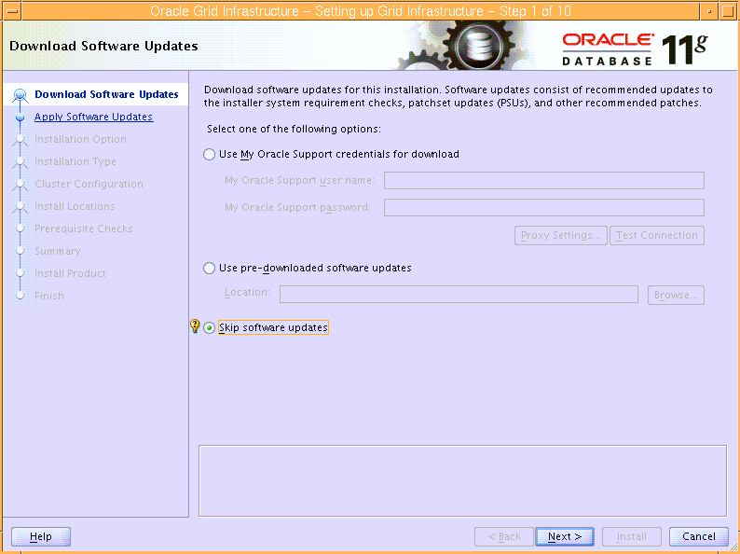
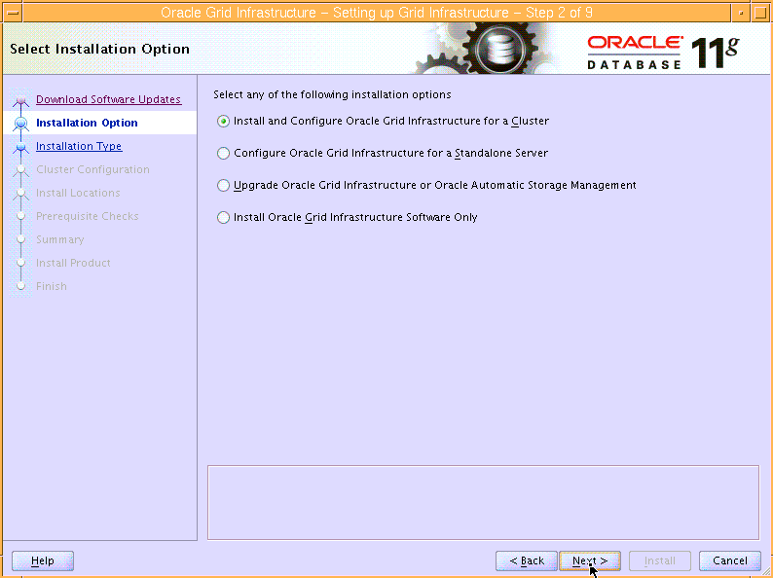

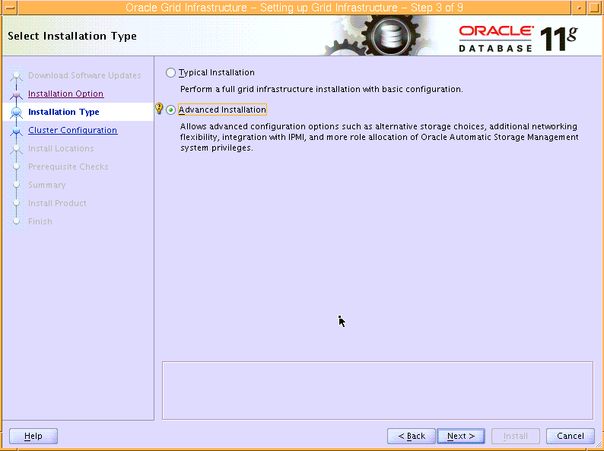

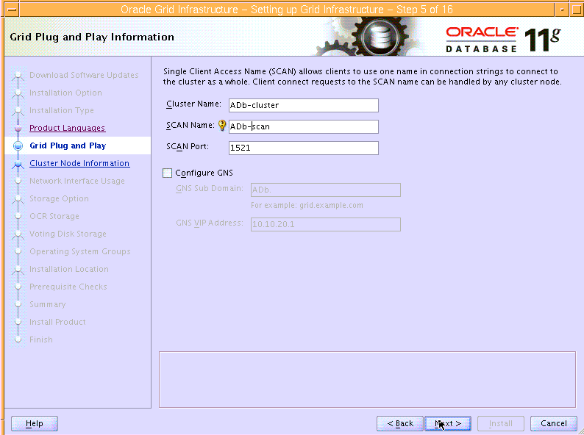

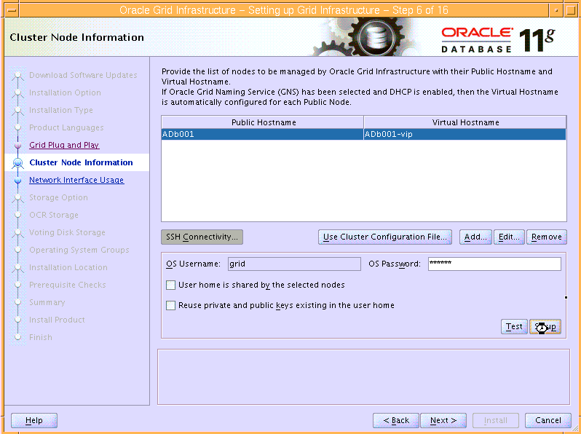
此时出现错误如下：
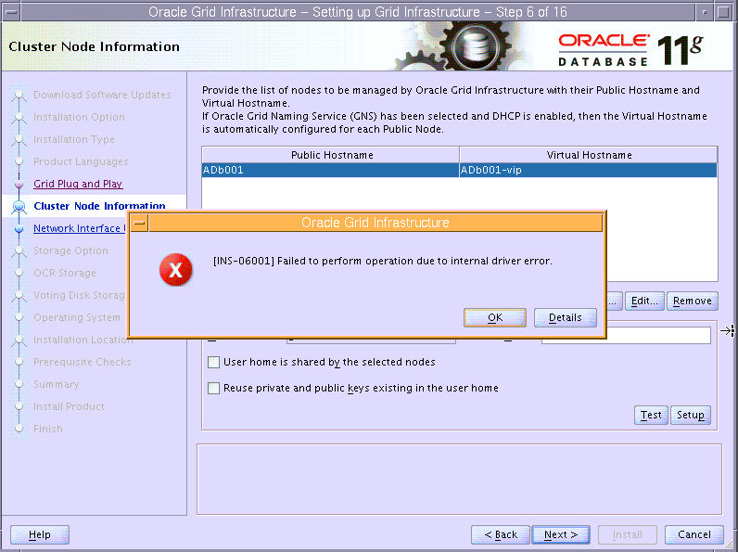

点Ok，手动配置ssh
$mkdir ~/.ssh
$chmod 700 ~/.ssh
$ssh-keygen -t rsa
Generating public/private rsa key pair.
Enter file in which to save the key (/home/oracle/.ssh/id_rsa):
Enter passphrase (empty for no passphrase):
Enter same passphrase again:
Your identification has been saved in /home/oracle/.ssh/id_rsa.
Your public key has been saved in /home/oracle/.ssh/id_rsa.pub.
The key fingerprint is:
bd:dc:85:05:6e:25:05:88:0c:55:2d:da:fb:ae:17:38 oracle@db01
The key's randomart image is:
+--[ RSA 2048]----+
| .+.o.o+oo |
| o o..+ |
| o .o . |
| .... o |
| S .o. . |
| .Eo.. |
| oo.. |
| o |
| .+. |
+-----------------+
$ ssh-keygen -t dsa
Generating public/private dsa key pair.
Enter file in which to save the key (/home/oracle/.ssh/id_dsa):
Enter passphrase (empty for no passphrase):
Enter same passphrase again:
Your identification has been saved in /home/oracle/.ssh/id_dsa.
Your public key has been saved in /home/oracle/.ssh/id_dsa.pub.
The key fingerprint is:
cc:a7:cd:ee:d3:ce:ad:0b:f3:b7:a6:6d:10:8a:53:32 oracle@db01
The key's randomart image is:
+--[ DSA 1024]----+
| |
| |
| |
| oE . . |
| S=.. . |
| o=. . |
| ..=. . |
| ..=.o+ |
| .ooBB+. |
+-----------------+
$ cat ~/.ssh/id_rsa.pub >> ~/.ssh/authorized_keys
$ cat ~/.ssh/id_dsa.pub >> ~/.ssh/authorized_keys
$ssh ADb001 date
$ssh ADb001-priv date
手工配置ssh等效性完毕（只有一个节点）
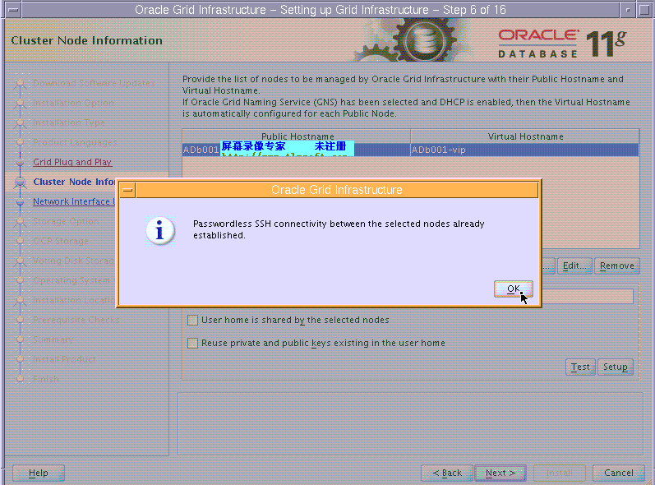
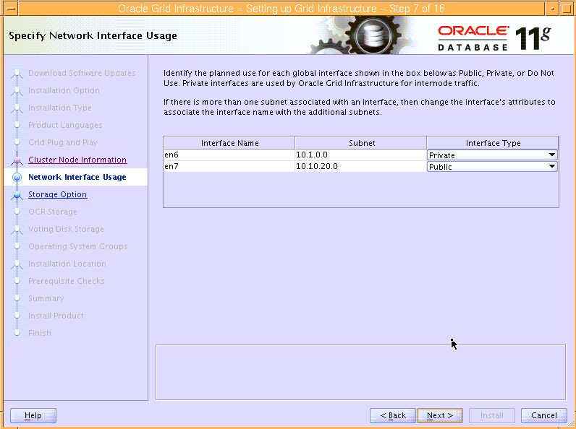
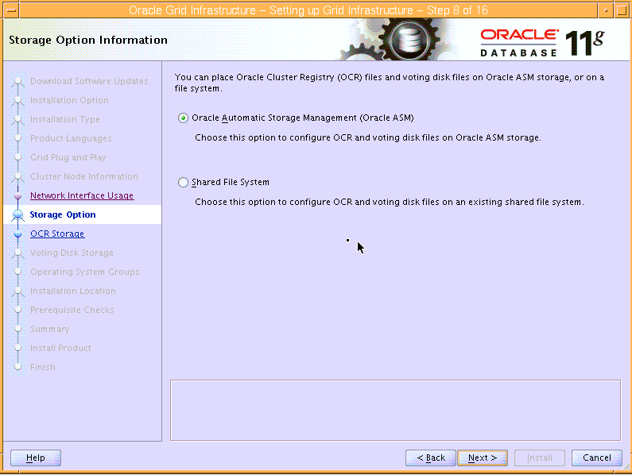

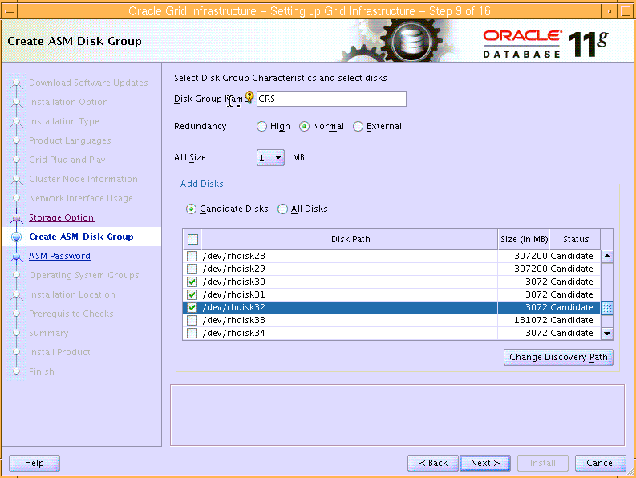

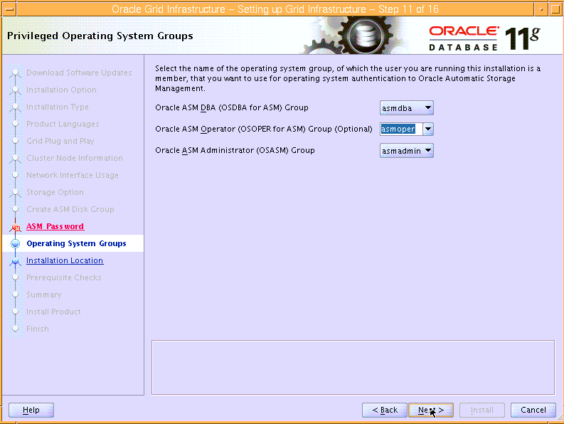

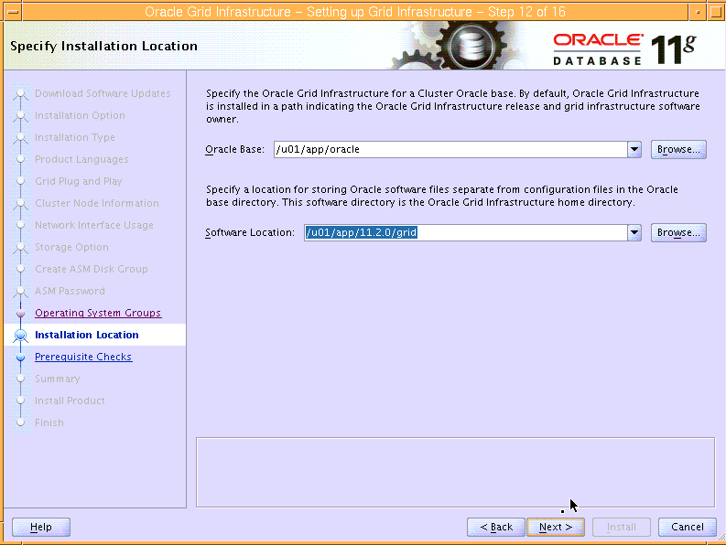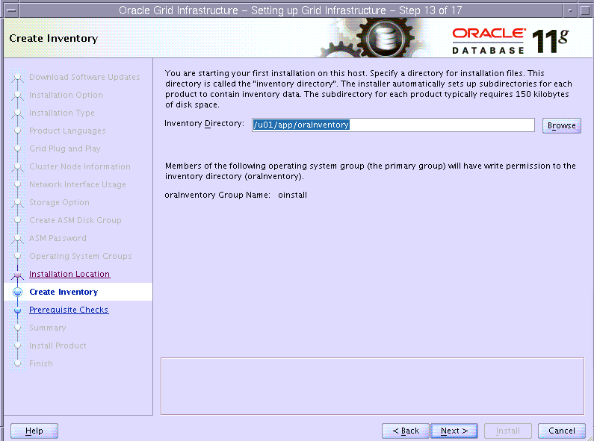

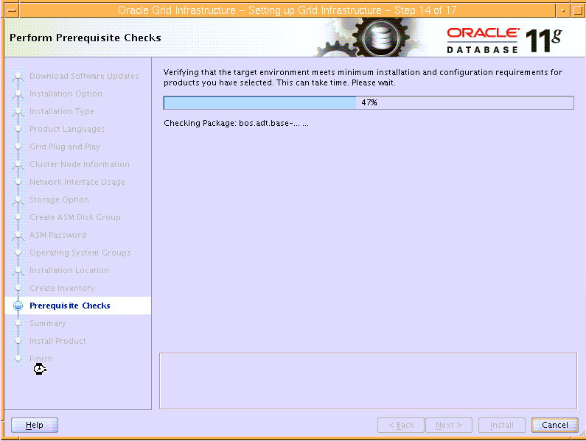
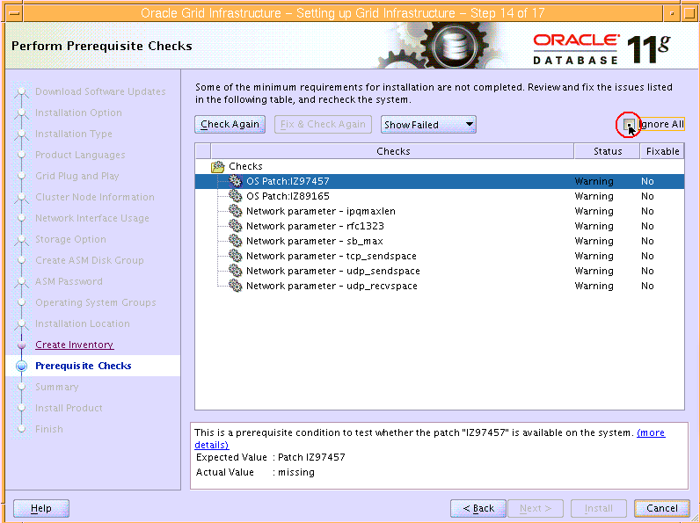

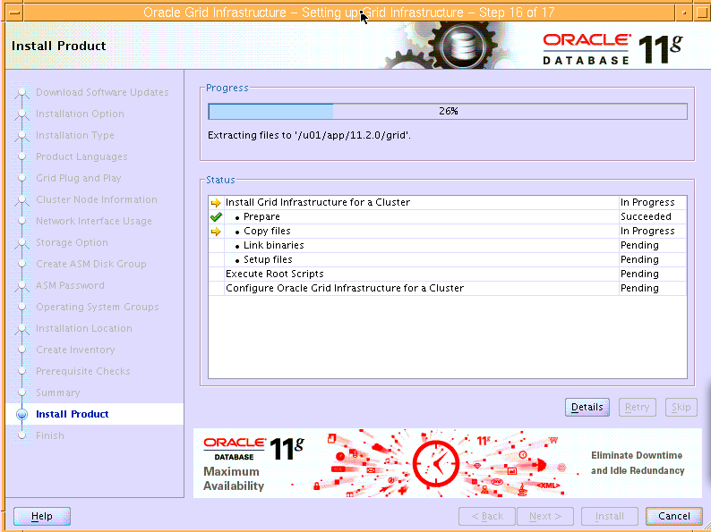
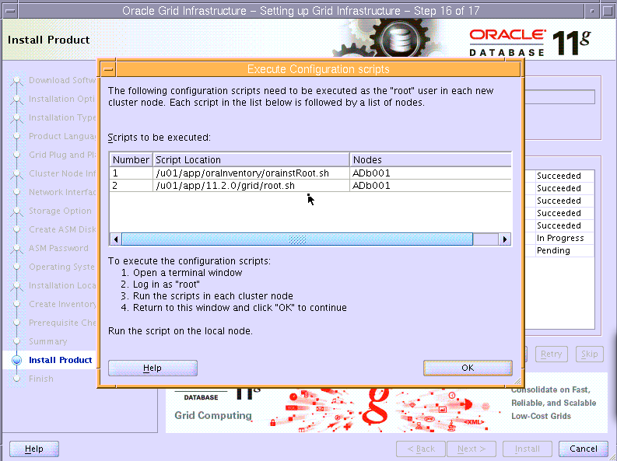
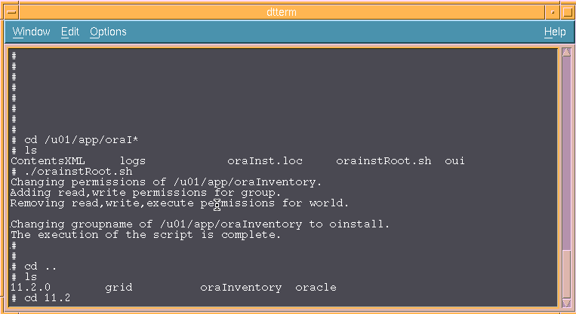
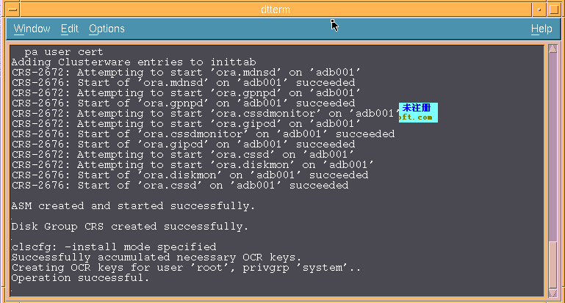

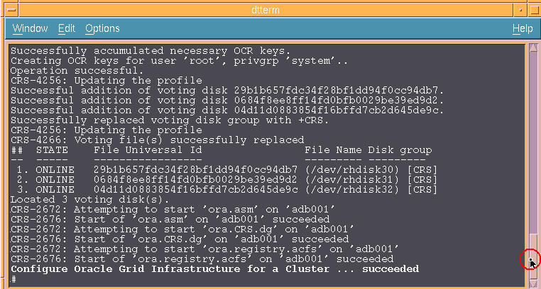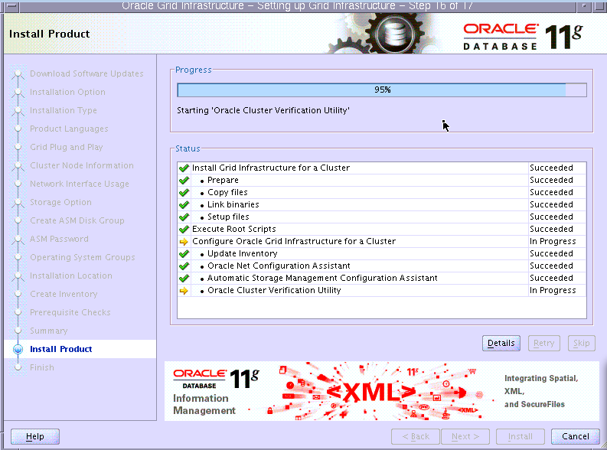
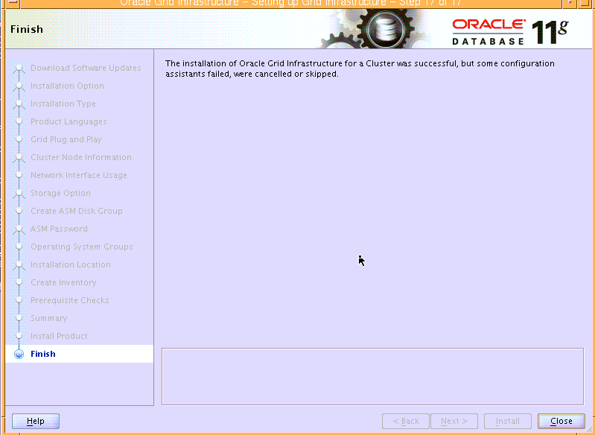
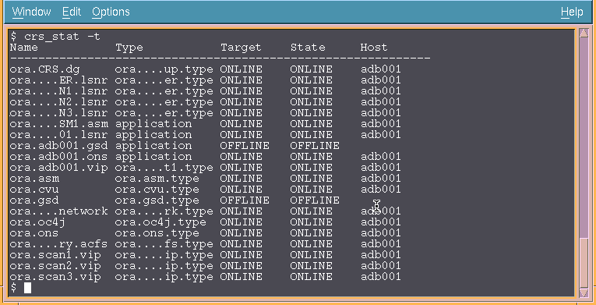
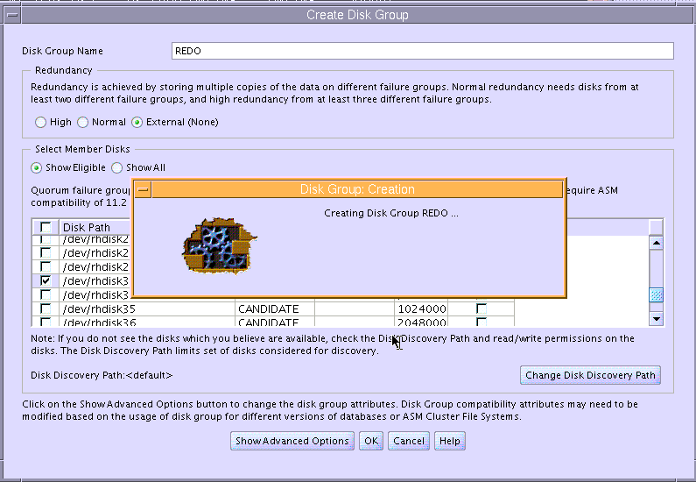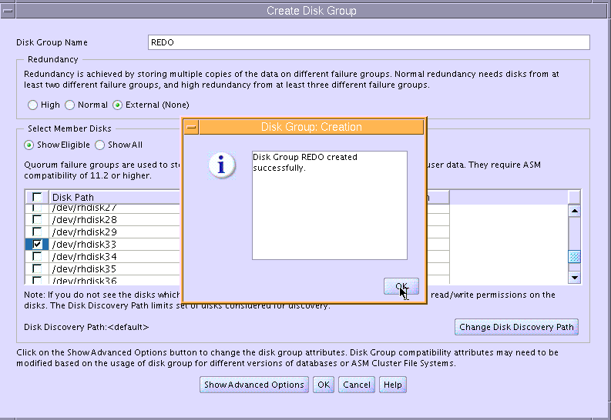
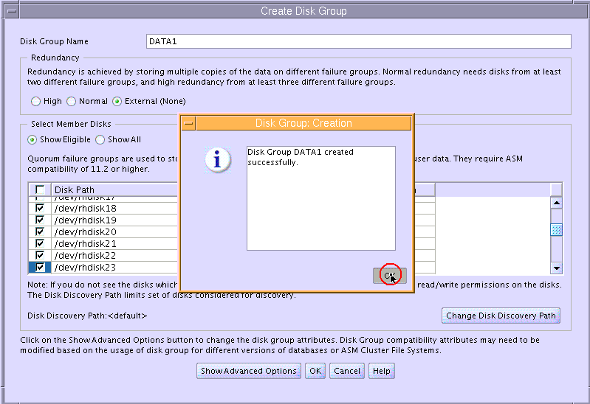

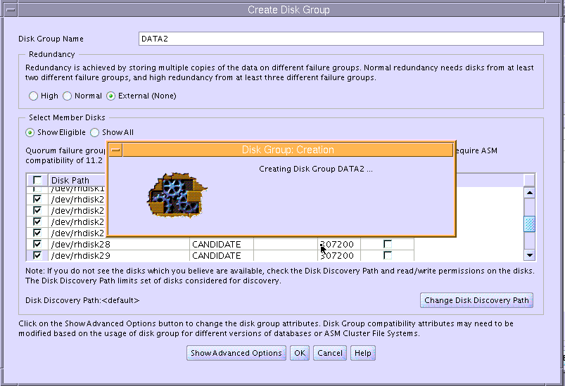

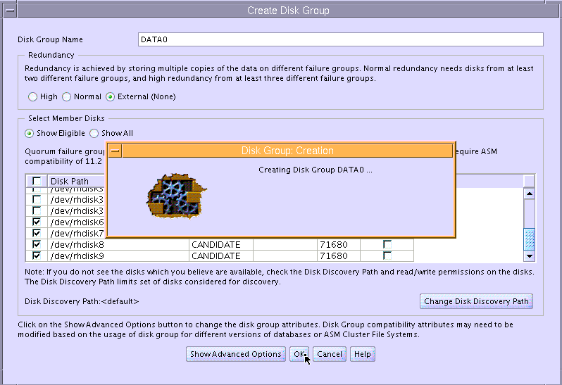

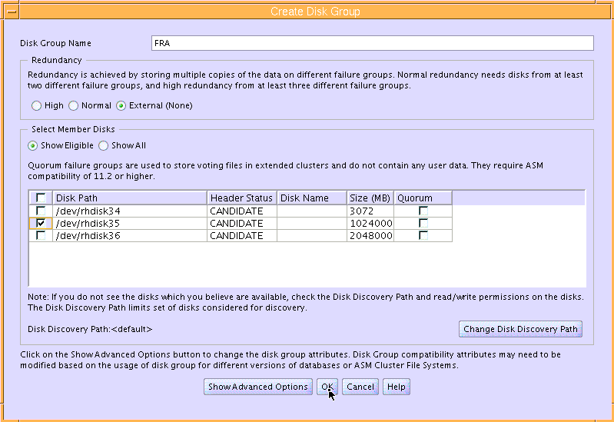

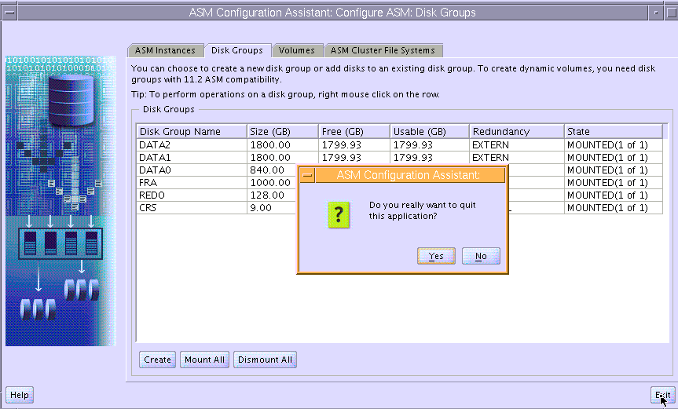

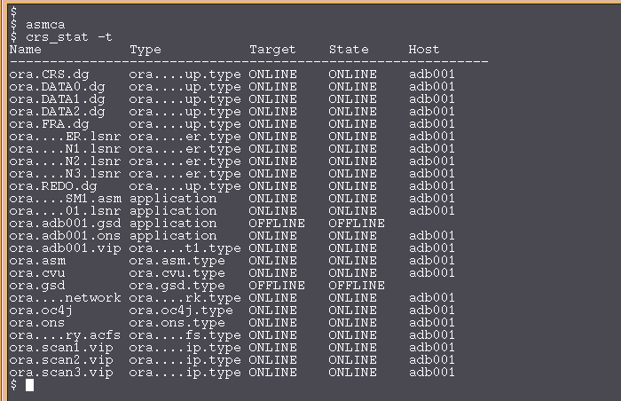

2.23安装database软件
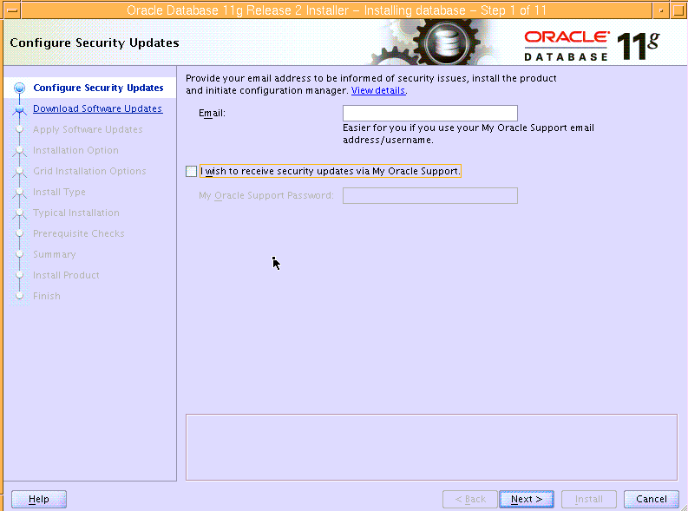
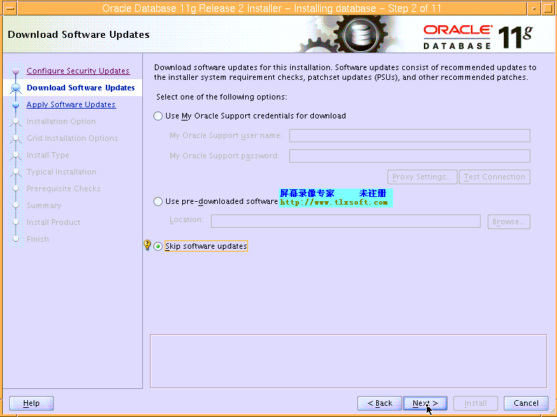
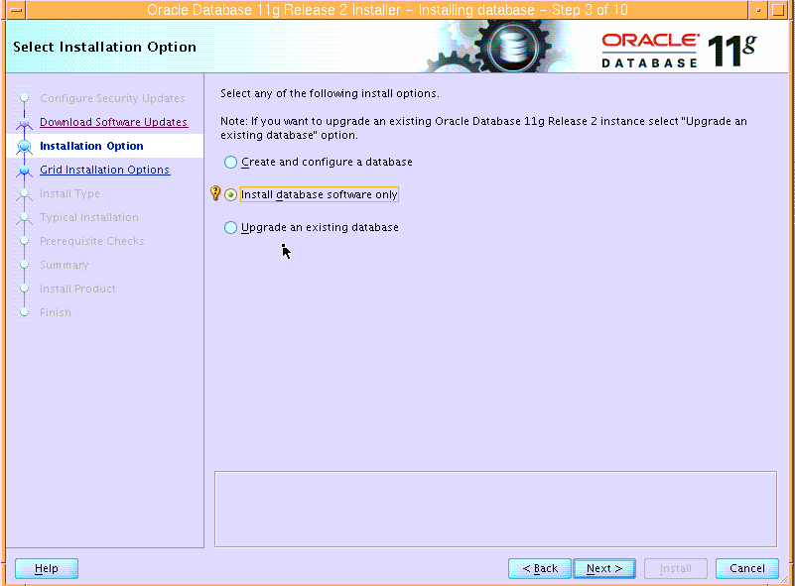
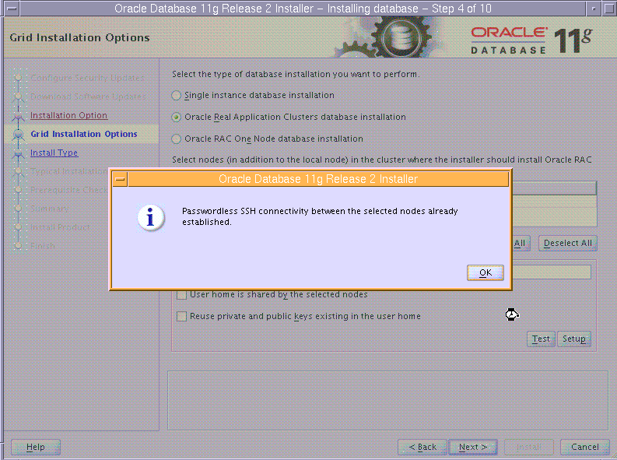
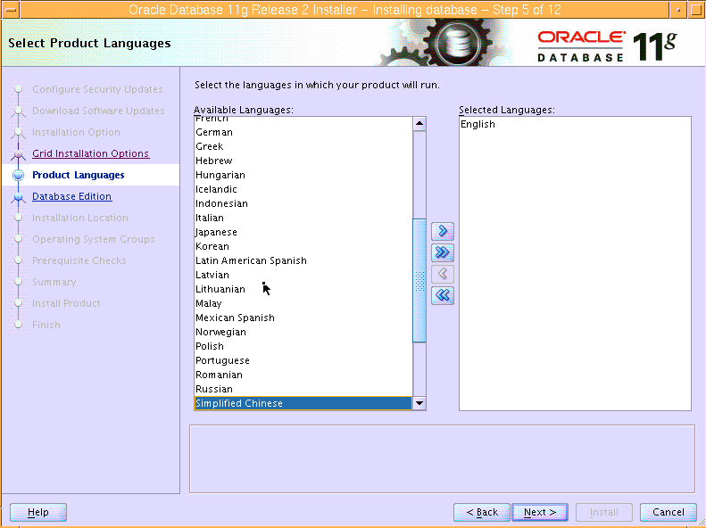
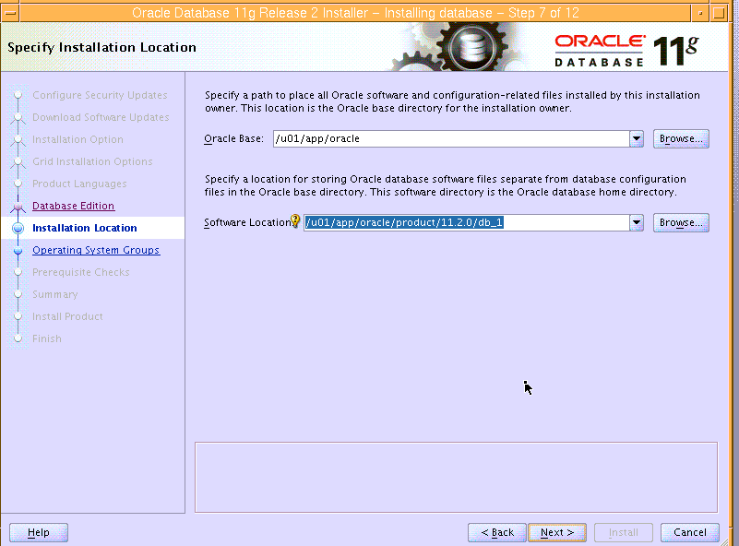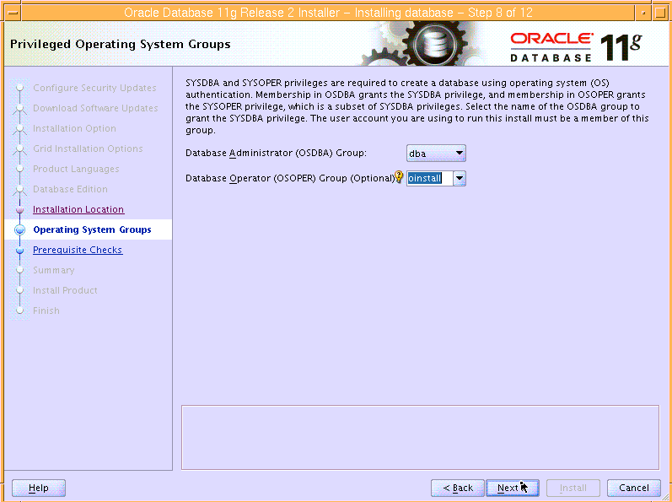
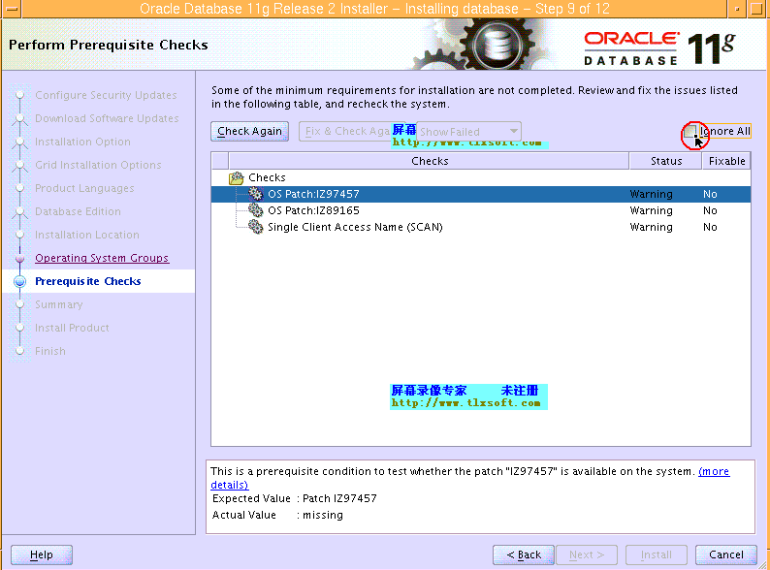
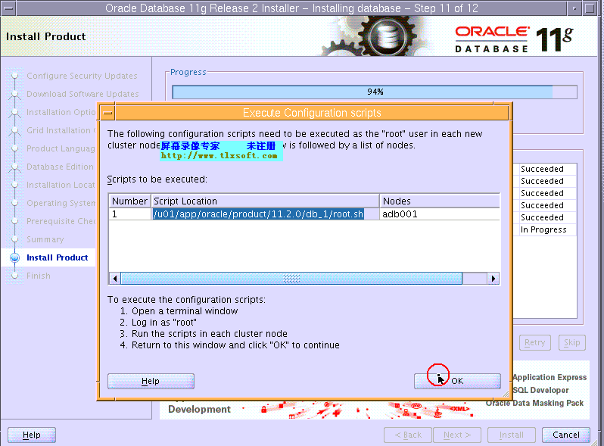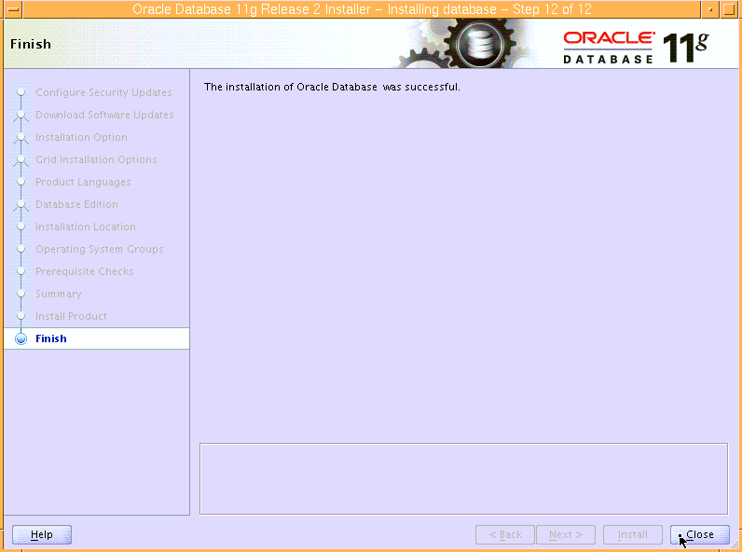
至此oracle单节点rac安装完毕。因为要做dataguard，故不需要dbca创建数据库。

三、单节点rac升级psu

3.1下载最新OPatch
最新OPatch版本为11.2.0.3.4详情见mos文章：
OPatch - 可以在什么位置找到最新版本的 OPatch？[视频] [ID 1525335.1]
2.2解压OPatch补丁
首先授予OPatch grid用户权限：

#chown grid:oinstall
以grid用户解压：
$unzip <OPATCH-ZIP> -d $GRID_HOME
$GRID_HOME/OPatch/opatch version
然后授予OPatch补丁包oracle用户权限并以oracle用户解压：
#chown oracle:oinstall
$ unzip <OPATCH-ZIP> -d $ORACLE_HOME
$OACLE_HOME/OPatch/opatch version

3.2检查补丁冲突
分别以grid用户和oracle用户执行如下命令：
Su - grid
$./opatch prereq CheckConflictAgainstOHWithDetail -phBaseDir /u01/orasoft/patch/13348650 -oh /u01/app/11.2.0/grid
Oracle Interim Patch Installer version 11.2.0.3.0
Copyright (c) 2012, Oracle Corporation. All rights reserved.

PREREQ session

Oracle Home : /u01/app/11.2.0/grid
Central Inventory : /u01/app/oraInventory
from : /u01/app/11.2.0/grid/oraInst.loc
OPatch version : 11.2.0.3.0
OUI version : 11.2.0.3.0
Log file location : /u01/app/11.2.0/grid/cfgtoollogs/opatch/opatch2013-04-18_00-50-03AM_1.log
Invoking prereq "checkconflictagainstohwithdetail"
Prereq "checkConflictAgainstOHWithDetail" passed.
OPatch succeeded.
$./opatch prereq CheckConflictAgainstOHWithDetail -phBaseDir /u01/orasoft/patch/13343438 -oh /u01/app/11.2.0/grid
Oracle Interim Patch Installer version 11.2.0.3.0
Copyright (c) 2012, Oracle Corporation. All rights reserved.

PREREQ session

Oracle Home : /u01/app/11.2.0/grid
Central Inventory : /u01/app/oraInventory
from : /u01/app/11.2.0/grid/oraInst.loc
OPatch version : 11.2.0.3.0
OUI version : 11.2.0.3.0
Log file location : /u01/app/11.2.0/grid/cfgtoollogs/opatch/opatch2013-04-18_00-50-20AM_1.log
Invoking prereq "checkconflictagainstohwithdetail"
Prereq "checkConflictAgainstOHWithDetail" passed.
OPatch succeeded.
Su - oracle
$ ./opatch prereq CheckConflictAgainstOHWithDetail -phBaseDir /u01/orasoft/patch/13348650 -oh /u01/app/oracle/product/11.2.0/db_1/
Oracle Interim Patch Installer version 11.2.0.3.0
Copyright (c) 2012, Oracle Corporation. All rights reserved.

PREREQ session

Oracle Home : /u01/app/oracle/product/11.2.0/db_1
Central Inventory : /u01/app/oraInventory
from : /u01/app/oracle/product/11.2.0/db_1//oraInst.loc
OPatch version : 11.2.0.3.0
OUI version : 11.2.0.3.0
Log file location : /u01/app/oracle/product/11.2.0/db_1/cfgtoollogs/opatch/opatch2013-04-18_00-50-53AM_1.log
Invoking prereq "checkconflictagainstohwithdetail"
Prereq "checkConflictAgainstOHWithDetail" passed.
OPatch succeeded.
$ ./opatch prereq CheckConflictAgainstOHWithDetail -phBaseDir /u01/orasoft/patch/13343438 -oh /u01/app/oracle/product/11.2.0/db_1/
Oracle Interim Patch Installer version 11.2.0.3.0
Copyright (c) 2012, Oracle Corporation. All rights reserved.

PREREQ session

Oracle Home : /u01/app/oracle/product/11.2.0/db_1
Central Inventory : /u01/app/oraInventory
from : /u01/app/oracle/product/11.2.0/db_1//oraInst.loc
OPatch version : 11.2.0.3.0
OUI version : 11.2.0.3.0
Log file location : /u01/app/oracle/product/11.2.0/db_1/cfgtoollogs/opatch/opatch2013-04-18_00-51-05AM_1.log
Invoking prereq "checkconflictagainstohwithdetail"
Prereq "checkConflictAgainstOHWithDetail" passed.
OPatch succeeded.

3.3正式打PSU
以grid用户执行如下命令来生成ocm.rsp响应文件
$GRID_HOME/OPatch/ocm/bin/emocmrsp

以root用户执行如下命令分别对grid和database升级：
#export PATH=$PATH:/u01/app/11.2.0/grid/OPatch
#opatch auto /u01/orasoft/patch -oh /u01/app/11.2.0/grid/ -ocmrf /u01/app/11.2.0/grid/OPatch/ocm/bin/ocm.rsp

Executing /usr/bin/perl /u01/app/11.2.0/grid/OPatch/crs/patch112.pl -patchdir /u01/orasoft -patchn patch -oh /u01/app/11.2.0/grid/ -ocmrf /u01/app/11.2.0/grid/OPatch/ocm/bin/ocm.rsp -paramfile /u01/app/11.2.0/grid/crs/install/crsconfig_params
opatch auto log file location is /u01/app/11.2.0/grid/OPatch/crs/../../cfgtoollogs/opatchauto2013-04-18_00-51-28.log
Detected Oracle Clusterware install
Using configuration parameter file: /u01/app/11.2.0/grid/crs/install/crsconfig_params
Enter 'yes' if you have unzipped this patch to an empty directory to proceed (yes/no):yes
Successfully unlock /u01/app/11.2.0/grid
patch /u01/orasoft/patch/13343438 apply successful for home /u01/app/11.2.0/grid
patch /u01/orasoft/patch/13348650 apply successful for home /u01/app/11.2.0/grid
ACFS-9300: ADVM/ACFS distribution files found.
ACFS-9312: Existing ADVM/ACFS installation detected.
ACFS-9314: Removing previous ADVM/ACFS installation.
This may take several minutes. Please wait ...
0518-307 odmdelete: 1 objects deleted.
0518-307 odmdelete: 1 objects deleted.
0518-307 odmdelete: 1 objects deleted.
ACFS-9315: Previous ADVM/ACFS components successfully removed.
ACFS-9307: Installing requested ADVM/ACFS software.
ACFS-9359: The AIX ODM entry for 'acfsctl' was successfully added.
ACFS-9359: The AIX ODM entry for 'advmctl' was successfully added.
ACFS-9359: The AIX ODM entry for 'advmvol' was successfully added.
ACFS-9308: Loading installed ADVM/ACFS drivers.
ACFS-9154: Loading 'oracleadvm.ext' driver.
ACFS-9154: Loading 'oracleacfs.ext' driver.
ACFS-9327: Verifying ADVM/ACFS devices.
ACFS-9156: Detecting control device '/dev/asm/.asm_ctl_spec'.
ACFS-9156: Detecting control device '/dev/ofsctl'.
ACFS-9309: ADVM/ACFS installation correctness verified.
CRS-4123: Oracle High Availability Services has been started.

#export PATH=$PATH:/u01/app/11.2.0/grid/OPatch/
#opatch auto /u01/orasoft/patch -oh /u01/app/oracle/product/11.2.0/db_1/ -ocmrf /u01/app/11.2.0/grid/OPatch/ocm/bin/ocm.rsp
Executing /usr/bin/perl /u01/app/11.2.0/grid/OPatch/crs/patch112.pl -patchdir /u01/orasoft -patchn patch -oh /u01/app/oracle/product/11.2.0/db_1/ -ocmrf /u01/app/11.2.0/grid/OPatch/ocm/bin/ocm.rsp -paramfile /u01/app/11.2.0/grid/crs/install/crsconfig_params
opatch auto log file location is /u01/app/11.2.0/grid/OPatch/crs/../../cfgtoollogs/opatchauto2013-04-18_01-14-46.log
Detected Oracle Clusterware install
Using configuration parameter file: /u01/app/11.2.0/grid/crs/install/crsconfig_params
Enter 'yes' if you have unzipped this patch to an empty directory to proceed (yes/no):yes
patch /u01/orasoft/patch/13343438 apply successful for home /u01/app/oracle/product/11.2.0/db_1
patch /u01/orasoft/patch/13348650/custom/server/13348650 apply successful for home /u01/app/oracle/product/11.2.0/db_1

至此11.2.0.3.1的补丁已经打完。

四、创建测试库
创建测试库通过rman备份主库数据restore至备库来进行测试。

4.1NFS目录创建
10.10.20.201为NFS服务器，该服务器的/rmanbak目录需要挂载至10.1.1.70（生产服务器）。
服务器端（10.10.20.201）执行：
# vi /etc/exports
/rmanbak -rw,root=db01,access=db01

#vi /etc/hosts
添加客户端的IP主机名：
10.1.1.70 db01

启动NFS：
#mknfs -N
0513-029 The portmap Subsystem is already active.
Multiple instances are not supported.
Starting NFS services:
0513-029 The biod Subsystem is already active.
Multiple instances are not supported.
0513-029 The nfsd Subsystem is already active.
Multiple instances are not supported.
0513-029 The rpc.mountd Subsystem is already active.
Multiple instances are not supported.
0513-029 The rpc.statd Subsystem is already active.
Multiple instances are not supported.
0513-029 The rpc.lockd Subsystem is already active.
Multiple instances are not supported.
Completed NFS services.

客户端（10.1.1.70）执行如下：
vi /etc/filesystems添加如下
/rmanbak:
dev = /rmanbak
vfs = nfs
nodename = 10.10.20.201
mount = flase
options=rw,bg,hard,intr,proto=tcp,vers=3,rsize=65536,wsize=65536,timeo=600
account = false

#vi /etc/hosts
添加服务器端的IP主机名
10.10.20.201 ADb001

挂载/rmanbak目录：
#mount /rmanbak

4.2备份主库
$vi /oracle/app/scripts/rmanbackup.sh
rman target / cmdfile=/home/oracle/scripts/backup.rcv log=/home/oracle/scripts/log_rman.log

$vi /home/oracle/scripts/backup.rcv(第一次备份未采用压缩)
run {
allocate channel d1 type disk;
allocate channel d2 type disk;
allocate channel d3 type disk;
allocate channel d4 type disk;
sql 'alter system archive log current';
backup full database include current controlfile format '/rmanbak/easdb_full_%U';
release channel d1;
release channel d2;
release channel d3;
release channel d4;
}
第二次执行备份：（采用压缩）
run {
allocate channel d1 type disk;
allocate channel d2 type disk;
allocate channel d3 type disk;
allocate channel d4 type disk;
sql 'alter system archive log current';
backup full database include current controlfile format '/rmanbak/easdb_full_%U';
sql 'alter system archive log current';
backup archivelog all format '/rmanbak/easdb_arch_%U';
release channel d1;
release channel d2;
release channel d3;
release channel d4;
}
从备份效率来看：
 | 备份时间 | 大小 | 恢复时间
未采用压缩 | 4小时6分钟 | 1090GB | 2.5小时
采用压缩 | 6小时30分钟 | 267GB | 6小时46分钟
通过对比执行效率来看,正式实施采用不加压缩备份方式。

DATA1磁盘组的IO
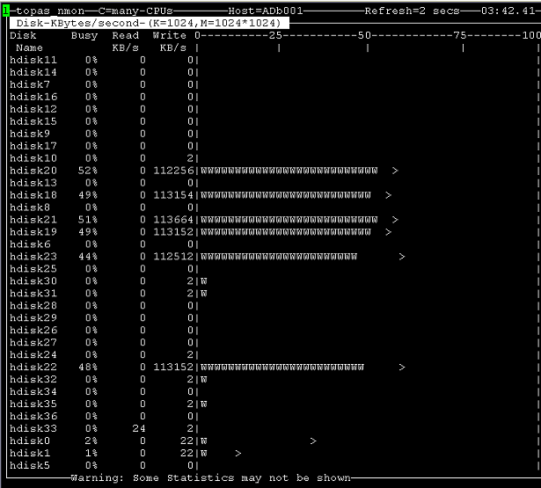

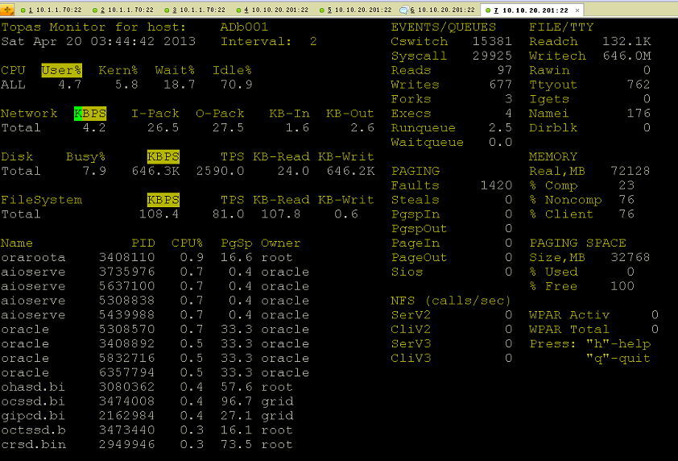

Data0磁盘组：
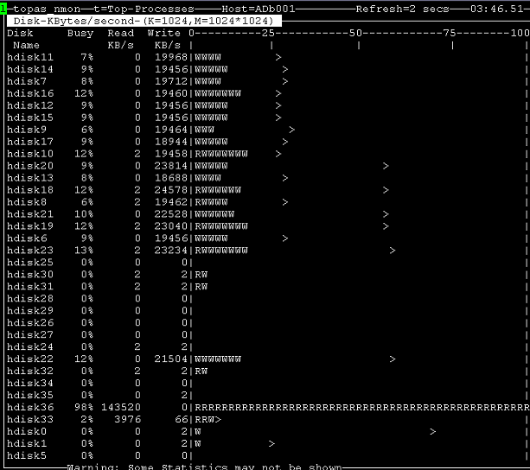

Data2磁盘组
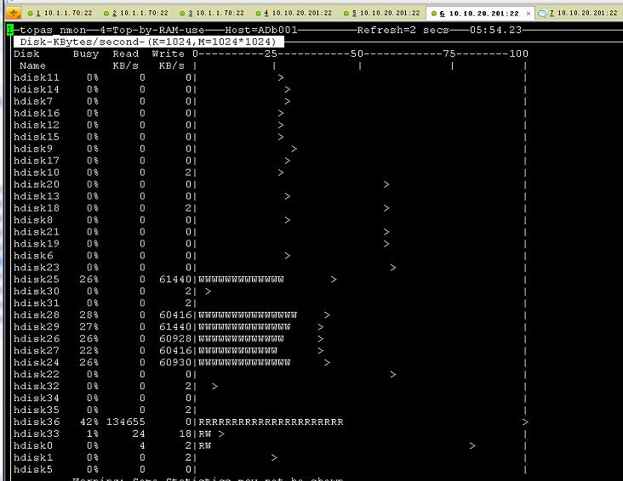

4.3在备库进行restore
将主库备份的pfile,controlfile拷贝至/rmanbak
在备库执行：
Rman target /
Rman>startup pfile=’/rmanbak/pfile20130419.ora’ nomount;
Oracle instance started

Total System Global Area 66809262080 bytes

Fixed Size 2238128 bytes
Variable Size 24696064336 bytes
Database Buffers 42010148864 bytes
Redo Buffers 100810752 bytes
Rman>restore controlfile to '+REDO/easdb/controlfile/control01.dbf' from '/rmanbak/c-762526345-20130418-03';
Starting restore at 18-APR-13
using target database control file instead of recovery catalog
allocated channel: ORA_DISK_1
channel ORA_DISK_1: SID=387 instance=easdb1 device type=DISK

channel ORA_DISK_1: restoring control file
channel ORA_DISK_1: restore complete, elapsed time: 00:00:01
Finished restore at 18-APR-13
Rman>restore controlfile to '+REDO/easdb/controlfile/control02.dbf' from '/rmanbak/c-762526345-20130418-03';
Starting restore at 18-APR-13
using target database control file instead of recovery catalog
allocated channel: ORA_DISK_1
channel ORA_DISK_1: SID=387 instance=easdb1 device type=DISK

channel ORA_DISK_1: restoring control file
channel ORA_DISK_1: restore complete, elapsed time: 00:00:01
Finished restore at 18-APR-13
Rman>startup mount;
database is already started
database mounted
released channel: ORA_DISK_1
执行如下restore脚本：(将数据分别恢复至DATA0、DATA1、DATA2磁盘组中)
run{
allocate channel d1 type disk;
allocate channel d2 type disk;
allocate channel d3 type disk;
allocate channel d4 type disk;
SET NEWNAME FOR DATAFILE 4 TO '+DATA0/easdb/datafile/users01.dbf';
SET NEWNAME FOR DATAFILE 3 TO '+DATA0/easdb/datafile/undotbs014.dbf';
SET NEWNAME FOR DATAFILE 2 TO '+DATA0/easdb/datafile/sysaux01.dbf';
SET NEWNAME FOR DATAFILE 1 TO '+DATA0/easdb/datafile/system01.dbf';
SET NEWNAME FOR DATAFILE 5 TO '+DATA0/easdb/datafile/undotbs024.dbf';
SET NEWNAME FOR DATAFILE 185 TO '+DATA0/easdb/datafile/system03.dbf';
SET NEWNAME FOR DATAFILE 165 TO '+DATA0/easdb/datafile/system02.dbf';
SET NEWNAME FOR DATAFILE 150 TO '+DATA0/easdb/datafile/sysaux02.dbf';
SET NEWNAME FOR DATAFILE 151 TO '+DATA0/easdb/datafile/sysaux03.dbf';
SET NEWNAME FOR DATAFILE 152 TO '+DATA0/easdb/datafile/sysaux04.dbf';
SET NEWNAME FOR DATAFILE 113 TO '+DATA0/easdb/datafile/undotbs011.dbf';
SET NEWNAME FOR DATAFILE 114 TO '+DATA0/easdb/datafile/undotbs012.dbf';
SET NEWNAME FOR DATAFILE 115 TO '+DATA0/easdb/datafile/undotbs013.dbf';
SET NEWNAME FOR DATAFILE 116 TO '+DATA0/easdb/datafile/undotbs021.dbf';
SET NEWNAME FOR DATAFILE 117 TO '+DATA0/easdb/datafile/undotbs022.dbf';
SET NEWNAME FOR DATAFILE 118 TO '+DATA0/easdb/datafile/undotbs023.dbf';
SET NEWNAME FOR DATAFILE 33 TO '+DATA0/easdb/datafile/eas_d_eastest_temp2001.dbf';
SET NEWNAME FOR DATAFILE 34 TO '+DATA0/easdb/datafile/eas_d_eastest_temp2002.dbf';
SET NEWNAME FOR DATAFILE 35 TO '+DATA0/easdb/datafile/eas_d_eastest_temp2003.dbf';
SET NEWNAME FOR DATAFILE 36 TO '+DATA0/easdb/datafile/eas_d_eastest_temp2004.dbf';
SET NEWNAME FOR DATAFILE 6 TO '+DATA0/easdb/datafile/eas_d_xxwlhcd_temp2001.dbf';
SET NEWNAME FOR DATAFILE 119 TO '+DATA0/easdb/datafile/eas_d_lhhr_temp2001.dbf';
SET NEWNAME FOR DATAFILE 102 TO '+DATA0/easdb/datafile/eas_d_lhjt2008_temp2001.dbf';
SET NEWNAME FOR DATAFILE 103 TO '+DATA0/easdb/datafile/eas_d_lhjt2008_temp2002.dbf';
SET NEWNAME FOR DATAFILE 104 TO '+DATA0/easdb/datafile/eas_d_lhjt2008_temp2003.dbf';
SET NEWNAME FOR DATAFILE 105 TO '+DATA0/easdb/datafile/eas_d_lhjt2008_temp2004.dbf';
SET NEWNAME FOR DATAFILE 106 TO '+DATA0/easdb/datafile/eas_d_lhjt2008_temp2005.dbf';
SET NEWNAME FOR DATAFILE 107 TO '+DATA0/easdb/datafile/eas_d_lhjt2008_temp2006.dbf';
SET NEWNAME FOR DATAFILE 146 TO '+DATA0/easdb/datafile/eas_d_lhjt2012_temp2001.dbf';
SET NEWNAME FOR DATAFILE 147 TO '+DATA0/easdb/datafile/eas_d_lhjt2012_temp2002.dbf';
SET NEWNAME FOR DATAFILE 148 TO '+DATA0/easdb/datafile/eas_d_lhjt2012_temp2003.dbf';
SET NEWNAME FOR DATAFILE 149 TO '+DATA0/easdb/datafile/eas_d_lhjt2012_temp2004.dbf';
SET NEWNAME FOR DATAFILE 166 TO '+DATA1/easdb/datafile/ekp01.dbf';
SET NEWNAME FOR DATAFILE 167 TO '+DATA1/easdb/datafile/ekp02.dbf';
SET NEWNAME FOR DATAFILE 7 TO '+DATA1/easdb/datafile/eas_d_xxwlhcd_standard001.dbf';
SET NEWNAME FOR DATAFILE 8 TO '+DATA1/easdb/datafile/eas_d_eastest_standard001.dbf';
SET NEWNAME FOR DATAFILE 9 TO '+DATA1/easdb/datafile/eas_d_eastest_standard002.dbf';
SET NEWNAME FOR DATAFILE 10 TO '+DATA1/easdb/datafile/eas_d_eastest_standard003.dbf';
SET NEWNAME FOR DATAFILE 11 TO '+DATA1/easdb/datafile/eas_d_eastest_standard004.dbf';
SET NEWNAME FOR DATAFILE 12 TO '+DATA1/easdb/datafile/eas_d_eastest_standard005.dbf';
SET NEWNAME FOR DATAFILE 13 TO '+DATA1/easdb/datafile/eas_d_eastest_standard006.dbf';
SET NEWNAME FOR DATAFILE 14 TO '+DATA1/easdb/datafile/eas_d_eastest_standard007.dbf';
SET NEWNAME FOR DATAFILE 15 TO '+DATA1/easdb/datafile/eas_d_eastest_standard008.dbf';
SET NEWNAME FOR DATAFILE 16 TO '+DATA1/easdb/datafile/eas_d_eastest_standard009.dbf';
SET NEWNAME FOR DATAFILE 17 TO '+DATA1/easdb/datafile/eas_d_eastest_standard010.dbf';
SET NEWNAME FOR DATAFILE 18 TO '+DATA1/easdb/datafile/eas_d_eastest_standard011.dbf';
SET NEWNAME FOR DATAFILE 19 TO '+DATA1/easdb/datafile/eas_d_eastest_standard012.dbf';
SET NEWNAME FOR DATAFILE 20 TO '+DATA1/easdb/datafile/eas_d_eastest_standard013.dbf';
SET NEWNAME FOR DATAFILE 21 TO '+DATA1/easdb/datafile/eas_d_eastest_standard014.dbf';
SET NEWNAME FOR DATAFILE 22 TO '+DATA1/easdb/datafile/eas_d_eastest_standard015.dbf';
SET NEWNAME FOR DATAFILE 23 TO '+DATA1/easdb/datafile/eas_d_eastest_standard016.dbf';
SET NEWNAME FOR DATAFILE 24 TO '+DATA1/easdb/datafile/eas_d_eastest_standard017.dbf';
SET NEWNAME FOR DATAFILE 25 TO '+DATA1/easdb/datafile/eas_d_eastest_standard018.dbf';
SET NEWNAME FOR DATAFILE 26 TO '+DATA1/easdb/datafile/eas_d_eastest_standard019.dbf';
SET NEWNAME FOR DATAFILE 27 TO '+DATA1/easdb/datafile/eas_d_eastest_standard020.dbf';
SET NEWNAME FOR DATAFILE 28 TO '+DATA1/easdb/datafile/eas_d_eastest_standard021.dbf';
SET NEWNAME FOR DATAFILE 29 TO '+DATA1/easdb/datafile/eas_d_eastest_standard022.dbf';
SET NEWNAME FOR DATAFILE 30 TO '+DATA1/easdb/datafile/eas_d_eastest_standard023.dbf';
SET NEWNAME FOR DATAFILE 31 TO '+DATA1/easdb/datafile/eas_d_eastest_standard024.dbf';
SET NEWNAME FOR DATAFILE 32 TO '+DATA1/easdb/datafile/eas_d_eastest_standard025.dbf';
SET NEWNAME FOR DATAFILE 37 TO '+DATA1/easdb/datafile/eas_d_lhjt2008_standard001.dbf';
SET NEWNAME FOR DATAFILE 38 TO '+DATA1/easdb/datafile/eas_d_lhjt2008_standard002.dbf';
SET NEWNAME FOR DATAFILE 39 TO '+DATA1/easdb/datafile/eas_d_lhjt2008_standard003.dbf';
SET NEWNAME FOR DATAFILE 40 TO '+DATA1/easdb/datafile/eas_d_lhjt2008_standard004.dbf';
SET NEWNAME FOR DATAFILE 41 TO '+DATA1/easdb/datafile/eas_d_lhjt2008_standard005.dbf';
SET NEWNAME FOR DATAFILE 42 TO '+DATA1/easdb/datafile/eas_d_lhjt2008_standard006.dbf';
SET NEWNAME FOR DATAFILE 43 TO '+DATA1/easdb/datafile/eas_d_lhjt2008_standard007.dbf';
SET NEWNAME FOR DATAFILE 44 TO '+DATA1/easdb/datafile/eas_d_lhjt2008_standard008.dbf';
SET NEWNAME FOR DATAFILE 45 TO '+DATA1/easdb/datafile/eas_d_lhjt2008_standard009.dbf';
SET NEWNAME FOR DATAFILE 46 TO '+DATA1/easdb/datafile/eas_d_lhjt2008_standard010.dbf';
SET NEWNAME FOR DATAFILE 47 TO '+DATA1/easdb/datafile/eas_d_lhjt2008_standard011.dbf';
SET NEWNAME FOR DATAFILE 48 TO '+DATA1/easdb/datafile/eas_d_lhjt2008_standard012.dbf';
SET NEWNAME FOR DATAFILE 49 TO '+DATA1/easdb/datafile/eas_d_lhjt2008_standard013.dbf';
SET NEWNAME FOR DATAFILE 50 TO '+DATA1/easdb/datafile/eas_d_lhjt2008_standard014.dbf';
SET NEWNAME FOR DATAFILE 51 TO '+DATA1/easdb/datafile/eas_d_lhjt2008_standard015.dbf';
SET NEWNAME FOR DATAFILE 52 TO '+DATA1/easdb/datafile/eas_d_lhjt2008_standard016.dbf';
SET NEWNAME FOR DATAFILE 53 TO '+DATA1/easdb/datafile/eas_d_lhjt2008_standard017.dbf';
SET NEWNAME FOR DATAFILE 54 TO '+DATA1/easdb/datafile/eas_d_lhjt2008_standard018.dbf';
SET NEWNAME FOR DATAFILE 55 TO '+DATA1/easdb/datafile/eas_d_lhjt2008_standard019.dbf';
SET NEWNAME FOR DATAFILE 56 TO '+DATA1/easdb/datafile/eas_d_lhjt2008_standard020.dbf';
SET NEWNAME FOR DATAFILE 57 TO '+DATA1/easdb/datafile/eas_d_lhjt2008_standard021.dbf';
SET NEWNAME FOR DATAFILE 58 TO '+DATA1/easdb/datafile/eas_d_lhjt2008_standard022.dbf';
SET NEWNAME FOR DATAFILE 59 TO '+DATA1/easdb/datafile/eas_d_lhjt2008_standard023.dbf';
SET NEWNAME FOR DATAFILE 60 TO '+DATA1/easdb/datafile/eas_d_lhjt2008_standard024.dbf';
SET NEWNAME FOR DATAFILE 61 TO '+DATA1/easdb/datafile/eas_d_lhjt2008_standard025.dbf';
SET NEWNAME FOR DATAFILE 62 TO '+DATA1/easdb/datafile/eas_d_lhjt2008_standard026.dbf';
SET NEWNAME FOR DATAFILE 63 TO '+DATA1/easdb/datafile/eas_d_lhjt2008_standard027.dbf';
SET NEWNAME FOR DATAFILE 64 TO '+DATA1/easdb/datafile/eas_d_lhjt2008_standard028.dbf';
SET NEWNAME FOR DATAFILE 65 TO '+DATA1/easdb/datafile/eas_d_lhjt2008_standard029.dbf';
SET NEWNAME FOR DATAFILE 66 TO '+DATA1/easdb/datafile/eas_d_lhjt2008_standard030.dbf';
SET NEWNAME FOR DATAFILE 67 TO '+DATA1/easdb/datafile/eas_d_lhjt2008_standard031.dbf';
SET NEWNAME FOR DATAFILE 68 TO '+DATA1/easdb/datafile/eas_d_lhjt2008_standard032.dbf';
SET NEWNAME FOR DATAFILE 69 TO '+DATA1/easdb/datafile/eas_d_lhjt2008_standard033.dbf';
SET NEWNAME FOR DATAFILE 70 TO '+DATA1/easdb/datafile/eas_d_lhjt2008_standard034.dbf';
SET NEWNAME FOR DATAFILE 71 TO '+DATA1/easdb/datafile/eas_d_lhjt2008_standard035.dbf';
SET NEWNAME FOR DATAFILE 72 TO '+DATA1/easdb/datafile/eas_d_lhjt2008_standard036.dbf';
SET NEWNAME FOR DATAFILE 73 TO '+DATA1/easdb/datafile/eas_d_lhjt2008_standard037.dbf';
SET NEWNAME FOR DATAFILE 74 TO '+DATA1/easdb/datafile/eas_d_lhjt2008_standard038.dbf';
SET NEWNAME FOR DATAFILE 75 TO '+DATA1/easdb/datafile/eas_d_lhjt2008_standard039.dbf';
SET NEWNAME FOR DATAFILE 76 TO '+DATA1/easdb/datafile/eas_d_lhjt2008_standard040.dbf';
SET NEWNAME FOR DATAFILE 77 TO '+DATA1/easdb/datafile/eas_d_lhjt2008_standard041.dbf';
SET NEWNAME FOR DATAFILE 78 TO '+DATA1/easdb/datafile/eas_d_lhjt2008_standard042.dbf';
SET NEWNAME FOR DATAFILE 79 TO '+DATA1/easdb/datafile/eas_d_lhjt2008_standard043.dbf';
SET NEWNAME FOR DATAFILE 80 TO '+DATA1/easdb/datafile/eas_d_lhjt2008_standard044.dbf';
SET NEWNAME FOR DATAFILE 81 TO '+DATA1/easdb/datafile/eas_d_lhjt2008_standard045.dbf';
SET NEWNAME FOR DATAFILE 82 TO '+DATA1/easdb/datafile/eas_d_lhjt2008_standard046.dbf';
SET NEWNAME FOR DATAFILE 83 TO '+DATA1/easdb/datafile/eas_d_lhjt2008_standard047.dbf';
SET NEWNAME FOR DATAFILE 84 TO '+DATA1/easdb/datafile/eas_d_lhjt2008_standard048.dbf';
SET NEWNAME FOR DATAFILE 85 TO '+DATA1/easdb/datafile/eas_d_lhjt2008_standard049.dbf';
SET NEWNAME FOR DATAFILE 86 TO '+DATA1/easdb/datafile/eas_d_lhjt2008_standard050.dbf';
SET NEWNAME FOR DATAFILE 87 TO '+DATA1/easdb/datafile/eas_d_lhjt2008_standard051.dbf';
SET NEWNAME FOR DATAFILE 88 TO '+DATA1/easdb/datafile/eas_d_lhjt2008_standard052.dbf';
SET NEWNAME FOR DATAFILE 89 TO '+DATA1/easdb/datafile/eas_d_lhjt2008_standard053.dbf';
SET NEWNAME FOR DATAFILE 90 TO '+DATA1/easdb/datafile/eas_d_lhjt2008_standard054.dbf';
SET NEWNAME FOR DATAFILE 91 TO '+DATA1/easdb/datafile/eas_d_lhjt2008_standard055.dbf';
SET NEWNAME FOR DATAFILE 92 TO '+DATA1/easdb/datafile/eas_d_lhjt2008_standard056.dbf';
SET NEWNAME FOR DATAFILE 93 TO '+DATA1/easdb/datafile/eas_d_lhjt2008_standard057.dbf';
SET NEWNAME FOR DATAFILE 94 TO '+DATA1/easdb/datafile/eas_d_lhjt2008_standard058.dbf';
SET NEWNAME FOR DATAFILE 95 TO '+DATA1/easdb/datafile/eas_d_lhjt2008_standard059.dbf';
SET NEWNAME FOR DATAFILE 96 TO '+DATA1/easdb/datafile/eas_d_lhjt2008_standard060.dbf';
SET NEWNAME FOR DATAFILE 97 TO '+DATA1/easdb/datafile/eas_d_lhjt2008_standard061.dbf';
SET NEWNAME FOR DATAFILE 98 TO '+DATA1/easdb/datafile/eas_d_lhjt2008_standard062.dbf';
SET NEWNAME FOR DATAFILE 99 TO '+DATA1/easdb/datafile/eas_d_lhjt2008_standard063.dbf';
SET NEWNAME FOR DATAFILE 100 TO '+DATA1/easdb/datafile/eas_d_lhjt2008_standard064.dbf';
SET NEWNAME FOR DATAFILE 101 TO '+DATA1/easdb/datafile/eas_d_lhjt2008_standard065.dbf';
SET NEWNAME FOR DATAFILE 108 TO '+DATA1/easdb/datafile/eas_d_lhjt2008_standard066.dbf';
SET NEWNAME FOR DATAFILE 109 TO '+DATA1/easdb/datafile/eas_d_lhjt2008_standard067.dbf';
SET NEWNAME FOR DATAFILE 110 TO '+DATA1/easdb/datafile/eas_d_lhjt2008_standard068.dbf';
SET NEWNAME FOR DATAFILE 111 TO '+DATA1/easdb/datafile/eas_d_lhjt2008_standard069.dbf';
SET NEWNAME FOR DATAFILE 112 TO '+DATA1/easdb/datafile/eas_d_lhjt2008_standard070.dbf';
SET NEWNAME FOR DATAFILE 120 TO '+DATA1/easdb/datafile/eas_d_lhhr_standard001.dbf';
SET NEWNAME FOR DATAFILE 168 TO '+DATA1/easdb/datafile/eas_d_xxwlhcd_standard002.dbf';
SET NEWNAME FOR DATAFILE 169 TO '+DATA1/easdb/datafile/eas_d_xxwlhcd_standard003.dbf';
SET NEWNAME FOR DATAFILE 191 TO '+DATA1/easdb/datafile/eas_d_xxwlhcd_standard004.dbf';
SET NEWNAME FOR DATAFILE 121 TO '+DATA2/easdb/datafile/eas_d_lhjt2012_standard001.dbf';
SET NEWNAME FOR DATAFILE 122 TO '+DATA2/easdb/datafile/eas_d_lhjt2012_standard002.dbf';
SET NEWNAME FOR DATAFILE 123 TO '+DATA2/easdb/datafile/eas_d_lhjt2012_standard003.dbf';
SET NEWNAME FOR DATAFILE 124 TO '+DATA2/easdb/datafile/eas_d_lhjt2012_standard004.dbf';
SET NEWNAME FOR DATAFILE 125 TO '+DATA2/easdb/datafile/eas_d_lhjt2012_standard005.dbf';
SET NEWNAME FOR DATAFILE 126 TO '+DATA2/easdb/datafile/eas_d_lhjt2012_standard006.dbf';
SET NEWNAME FOR DATAFILE 127 TO '+DATA2/easdb/datafile/eas_d_lhjt2012_standard007.dbf';
SET NEWNAME FOR DATAFILE 128 TO '+DATA2/easdb/datafile/eas_d_lhjt2012_standard008.dbf';
SET NEWNAME FOR DATAFILE 129 TO '+DATA2/easdb/datafile/eas_d_lhjt2012_standard009.dbf';
SET NEWNAME FOR DATAFILE 130 TO '+DATA2/easdb/datafile/eas_d_lhjt2012_standard010.dbf';
SET NEWNAME FOR DATAFILE 131 TO '+DATA2/easdb/datafile/eas_d_lhjt2012_standard011.dbf';
SET NEWNAME FOR DATAFILE 132 TO '+DATA2/easdb/datafile/eas_d_lhjt2012_standard012.dbf';
SET NEWNAME FOR DATAFILE 133 TO '+DATA2/easdb/datafile/eas_d_lhjt2012_standard013.dbf';
SET NEWNAME FOR DATAFILE 134 TO '+DATA2/easdb/datafile/eas_d_lhjt2012_standard014.dbf';
SET NEWNAME FOR DATAFILE 135 TO '+DATA2/easdb/datafile/eas_d_lhjt2012_standard015.dbf';
SET NEWNAME FOR DATAFILE 136 TO '+DATA2/easdb/datafile/eas_d_lhjt2012_standard016.dbf';
SET NEWNAME FOR DATAFILE 137 TO '+DATA2/easdb/datafile/eas_d_lhjt2012_standard017.dbf';
SET NEWNAME FOR DATAFILE 138 TO '+DATA2/easdb/datafile/eas_d_lhjt2012_standard018.dbf';
SET NEWNAME FOR DATAFILE 139 TO '+DATA2/easdb/datafile/eas_d_lhjt2012_standard019.dbf';
SET NEWNAME FOR DATAFILE 140 TO '+DATA2/easdb/datafile/eas_d_lhjt2012_standard020.dbf';
SET NEWNAME FOR DATAFILE 141 TO '+DATA2/easdb/datafile/eas_d_lhjt2012_standard021.dbf';
SET NEWNAME FOR DATAFILE 142 TO '+DATA2/easdb/datafile/eas_d_lhjt2012_standard022.dbf';
SET NEWNAME FOR DATAFILE 143 TO '+DATA2/easdb/datafile/eas_d_lhjt2012_standard023.dbf';
SET NEWNAME FOR DATAFILE 144 TO '+DATA2/easdb/datafile/eas_d_lhjt2012_standard024.dbf';
SET NEWNAME FOR DATAFILE 145 TO '+DATA2/easdb/datafile/eas_d_lhjt2012_standard025.dbf';
SET NEWNAME FOR DATAFILE 153 TO '+DATA2/easdb/datafile/eas_d_lhjt2012_standard026.dbf';
SET NEWNAME FOR DATAFILE 154 TO '+DATA2/easdb/datafile/eas_d_lhjt2012_standard027.dbf';
SET NEWNAME FOR DATAFILE 155 TO '+DATA2/easdb/datafile/eas_d_lhjt2012_standard028.dbf';
SET NEWNAME FOR DATAFILE 156 TO '+DATA2/easdb/datafile/eas_d_lhjt2012_standard029.dbf';
SET NEWNAME FOR DATAFILE 157 TO '+DATA2/easdb/datafile/eas_d_lhjt2012_standard030.dbf';
SET NEWNAME FOR DATAFILE 158 TO '+DATA2/easdb/datafile/eas_d_lhjt2012_standard031.dbf';
SET NEWNAME FOR DATAFILE 159 TO '+DATA2/easdb/datafile/eas_d_lhjt2012_standard032.dbf';
SET NEWNAME FOR DATAFILE 160 TO '+DATA2/easdb/datafile/eas_d_lhjt2012_standard033.dbf';
SET NEWNAME FOR DATAFILE 161 TO '+DATA2/easdb/datafile/eas_d_lhjt2012_standard034.dbf';
SET NEWNAME FOR DATAFILE 162 TO '+DATA2/easdb/datafile/eas_d_lhjt2012_standard035.dbf';
SET NEWNAME FOR DATAFILE 163 TO '+DATA2/easdb/datafile/eas_d_lhjt2012_standard036.dbf';
SET NEWNAME FOR DATAFILE 164 TO '+DATA2/easdb/datafile/eas_d_lhjt2012_standard037.dbf';
SET NEWNAME FOR DATAFILE 170 TO '+DATA2/easdb/datafile/eas_d_lhjt2012_standard038.dbf';
SET NEWNAME FOR DATAFILE 171 TO '+DATA2/easdb/datafile/eas_d_lhjt2012_standard039.dbf';
SET NEWNAME FOR DATAFILE 172 TO '+DATA2/easdb/datafile/eas_d_lhjt2012_standard040.dbf';
SET NEWNAME FOR DATAFILE 173 TO '+DATA2/easdb/datafile/eas_d_lhjt2012_standard041.dbf';
SET NEWNAME FOR DATAFILE 174 TO '+DATA2/easdb/datafile/eas_d_lhjt2012_standard042.dbf';
SET NEWNAME FOR DATAFILE 175 TO '+DATA2/easdb/datafile/eas_d_lhjt2012_standard043.dbf';
SET NEWNAME FOR DATAFILE 176 TO '+DATA2/easdb/datafile/eas_d_lhjt2012_standard044.dbf';
SET NEWNAME FOR DATAFILE 177 TO '+DATA2/easdb/datafile/eas_d_lhjt2012_standard045.dbf';
SET NEWNAME FOR DATAFILE 178 TO '+DATA2/easdb/datafile/eas_d_lhjt2012_standard046.dbf';
SET NEWNAME FOR DATAFILE 179 TO '+DATA2/easdb/datafile/eas_d_lhjt2012_standard047.dbf';
SET NEWNAME FOR DATAFILE 180 TO '+DATA2/easdb/datafile/eas_d_lhjt2012_standard048.dbf';
SET NEWNAME FOR DATAFILE 181 TO '+DATA2/easdb/datafile/eas_d_lhjt2012_standard049.dbf';
SET NEWNAME FOR DATAFILE 182 TO '+DATA2/easdb/datafile/eas_d_lhjt2012_standard050.dbf';
SET NEWNAME FOR DATAFILE 183 TO '+DATA2/easdb/datafile/eas_d_lhjt2012_standard051.dbf';
SET NEWNAME FOR DATAFILE 184 TO '+DATA2/easdb/datafile/eas_d_lhjt2012_standard052.dbf';
SET NEWNAME FOR DATAFILE 186 TO '+DATA2/easdb/datafile/eas_d_lhjt2012_standard053.dbf';
SET NEWNAME FOR DATAFILE 187 TO '+DATA2/easdb/datafile/eas_d_lhjt2012_standard054.dbf';
SET NEWNAME FOR DATAFILE 188 TO '+DATA2/easdb/datafile/eas_d_lhjt2012_standard055.dbf';
SET NEWNAME FOR DATAFILE 189 TO '+DATA2/easdb/datafile/eas_d_lhjt2012_standard056.dbf';
SET NEWNAME FOR DATAFILE 190 TO '+DATA2/easdb/datafile/eas_d_lhjt2012_standard057.dbf';
restore database;
switch datafile all;
release channel d1;
release channel d2;
release channel d3;
release channel d4;
}
对测试库进行不完全恢复：
catalog start with '/rmanbak/arch/';（catalog新备份的所有归档，让控制文件识别）

run{
allocate channel d1 type disk;
allocate channel d2 type disk;
allocate channel d3 type disk;
allocate channel d4 type disk;
set until sequence 18336 thread 2;
recover database;
release channel d1;
release channel d2;
release channel d3;
release channel d4;
}

Sql>alter database open resetlogs;
完成测试库的搭建后，由应用方进行压力测试。

五、正式实施--dataguard搭建

5.1设置主库force logging
Sql>alter database force logging;

5.2修改主库（rac端）参数
sql>ALTER SYSTEM SET LOG_ARCHIVE_CONFIG='DG_CONFIG=(easdb,standby)' scope=both;
sql>ALTER SYSTEM SET LOG_ARCHIVE_DEST_1='LOCATION=+FRA VALID_FOR=(ALL_LOGFILES,ALL_ROLES) DB_UNIQUE_NAME=easdb' scope=both;
sql>ALTER SYSTEM SET LOG_ARCHIVE_DEST_2='SERVICE=standby LGWR ASYNC AFFIRM VALID_FOR=(ONLINE_LOGFILES,PRIMARY_ROLE) DB_UNIQUE_NAME=standby' scope=both;
sql>ALTER SYSTEM SET LOG_ARCHIVE_DEST_STATE_1=enable scope=both;
sql>ALTER SYSTEM SET LOG_ARCHIVE_DEST_STATE_2=enable scope=both;
sql>ALTER SYSTEM SET FAL_CLIENT = easdb scope=both;
sql>ALTER SYSTEM SET FAL_SERVER = standby scope=both;
sql>ALTER SYSTEM SET STANDBY_FILE_MANAGEMENT =AUTO scope=both;

5.3为备端创建修改pfile
修改后pfile如下：
easdb2.__db_cache_size=39862665216
easdb1.__oracle_base='/u01/app/oracle'#ORACLE_BASE set from environment
easdb2.__oracle_base='/u01/app/oracle'#ORACLE_BASE set from environment
easdb2.__shared_pool_size=17985175552
*._b_tree_bitmap_plans=FALSE
*._no_or_expansion=TRUE
*.audit_file_dest='/u01/app/oracle/admin/easdb/adump'
*.audit_trail='db'
*.cluster_database=true
*.compatible='11.2.0.0.0'
*.control_files='+REDO/easdb/controlfile/control01.ctl','+REDO/easdb/controlfile/control02.ctl'
*.db_block_size=8192
*.db_cache_size=30000m
*.db_domain=''
*.db_name='easdb'
*.db_unique_name='standby'
*.deferred_segment_creation=FALSE
*.diagnostic_dest='/u01/app/oracle'
*.dispatchers='(PROTOCOL=TCP) (SERVICE=easdbXDB)'
*.fal_client='STANDBY'
*.fal_server='EASDB'
easdb1.instance_number=1
easdb2.instance_number=2
*.java_pool_size=100m
*.large_pool_size=200m
*.log_archive_config='DG_CONFIG=(easdb,standby)'
*.log_archive_dest_1='LOCATION=+FRA VALID_FOR=(ALL_LOGFILES,ALL_ROLES) DB_UNIQUE_NAME=standby'
*.log_archive_dest_2='SERVICE=easdb LGWR SYNC AFFIRM VALID_FOR=(ONLINE_LOGFILES,PRIMARY_ROLE) DB_UNIQUE_NAME=easdb'
*.log_archive_dest_state_1='ENABLE'
*.log_archive_dest_state_2='ENABLE'
*.log_archive_format='%t_%s_%r.dbf'
*.memory_max_target=62277025792
*.open_cursors=2000
*.optimizer_index_caching=90
*.optimizer_index_cost_adj=50
*.pga_aggregate_target=8000m
*.processes=1000
*.recyclebin='OFF'
*.remote_listener='ADb-scan:1521'
*.remote_login_passwordfile='exclusive'
*.sessions=1105
*.sga_max_size=53687091200
*.sga_target=53687091200
*.shared_pool_size=10000m
*.standby_file_management='AUTO'
*.streams_pool_size=200m
easdb2.thread=2
easdb1.thread=1
easdb2.undo_tablespace='UNDOTBS2'
easdb1.undo_tablespace='UNDOTBS1'

5.4修改主库tnsnames.ora
修改后内容如下：
EASDB =
(DESCRIPTION =
(ADDRESS = (PROTOCOL = TCP)(HOST = 10.1.1.71)(PORT = 1521))
(ADDRESS = (PROTOCOL = TCP)(HOST = 10.1.1.73)(PORT = 1521))
(CONNECT_DATA =
(SERVER = DEDICATED)
(SERVICE_NAME = easdb)
)
)

standby =
(DESCRIPTION =
(ADDRESS = (PROTOCOL = TCP)(HOST = 10.10.20.201)(PORT = 1521))
(CONNECT_DATA =
(SERVICE_NAME = standby)
(SID =easdb)
)
)

easdb1 =
(DESCRIPTION =
(ADDRESS = (PROTOCOL = TCP)(HOST = 10.1.1.71)(PORT = 1521))
(CONNECT_DATA =
(SID = easdb1)
)
)

easdb2 =
(DESCRIPTION =
(ADDRESS = (PROTOCOL = TCP)(HOST = 10.1.1.73)(PORT = 1521))
(CONNECT_DATA =
(SID = easdb2)
)
)

修改完成后将该文件复制到主端另一节点以及备端的相应位置
使用tnsping在主备端分别执行以下命令以测试连通性：
Tnsping standby
Tnsping easdb1
Tnsping easdb2

5.5修改hosts文件
在主端两个节点的（P740rac）hosts文件中分别添加备端地址：
10.10.20.201 ADb001

在备端（p570）添加主端的ip地址：
10.1.1.70 db01
10.1.1.71 db01-vip
10.1.1.72 db02
10.1.1.73 db02-vip

5.6备份数据库
通过如下脚本对数据库进行全备：
run {
allocate channel d1 type disk;
allocate channel d2 type disk;
allocate channel d3 type disk;
allocate channel d4 type disk;
sql 'alter system archive log current';
backup full database format='/rmanbak/easdb_full_%U' include current controlfile for standby;
sql 'alter system archive log current';
backup archivelog all format '/rmanbak/easdb_arch_%U';
release channel d1;
release channel d2;
release channel d3;
release channel d4;
}

5.7备份for standby控制文件
在主端执行：
Sql>alter database create standby controlfile as ‘/rmanbak/controldg.ctl’;

5.8复制密码文件
将主端$ORACLE_HOME/dbs/orapweasdb1文件复制到备端相同位置
Scp $ORACLE_HOME/dbs/orapweasdb1 oracle@10.10.20.201:$ORACLE_HOME/dbs/

5.9恢复备库
启动数据库至nomount状态
Rman target /
Rman>set dbid= 762526345
Rman> startup nomount pfile=’/rmanbak/pfiledg.ora’;
恢复控制文件
Rman> restore controlfile to '+REDO/easdb/controlfile/control01.ctl' from '/rmanbak/controldg.ctl';
Rman> restore controlfile to '+REDO/easdb/controlfile/control02.ctl' from '/rmanbak/controldg.ctl';
Restore database
Rman> run{
allocate channel d1 type disk;
allocate channel d2 type disk;
allocate channel d3 type disk;
allocate channel d4 type disk;
SET NEWNAME FOR DATAFILE 4 TO '+DATA0/easdb/datafile/users01.dbf';
SET NEWNAME FOR DATAFILE 3 TO '+DATA0/easdb/datafile/undotbs014.dbf';
SET NEWNAME FOR DATAFILE 2 TO '+DATA0/easdb/datafile/sysaux01.dbf';
SET NEWNAME FOR DATAFILE 150 TO '+DATA0/easdb/datafile/sysaux02.dbf';
SET NEWNAME FOR DATAFILE 151 TO '+DATA0/easdb/datafile/sysaux03.dbf';
SET NEWNAME FOR DATAFILE 152 TO '+DATA0/easdb/datafile/sysaux04.dbf';
SET NEWNAME FOR DATAFILE 1 TO '+DATA0/easdb/datafile/system01.dbf';
SET NEWNAME FOR DATAFILE 165 TO '+DATA0/easdb/datafile/system02.dbf';
SET NEWNAME FOR DATAFILE 185 TO '+DATA0/easdb/datafile/system03.dbf';
SET NEWNAME FOR DATAFILE 113 TO '+DATA0/easdb/datafile/undotbs011.dbf';
SET NEWNAME FOR DATAFILE 114 TO '+DATA0/easdb/datafile/undotbs012.dbf';
SET NEWNAME FOR DATAFILE 115 TO '+DATA0/easdb/datafile/undotbs013.dbf';
SET NEWNAME FOR DATAFILE 116 TO '+DATA0/easdb/datafile/undotbs021.dbf';
SET NEWNAME FOR DATAFILE 117 TO '+DATA0/easdb/datafile/undotbs022.dbf';
SET NEWNAME FOR DATAFILE 118 TO '+DATA0/easdb/datafile/undotbs023.dbf';
SET NEWNAME FOR DATAFILE 5 TO '+DATA0/easdb/datafile/undotbs024.dbf';
SET NEWNAME FOR DATAFILE 102 TO '+DATA0/easdb/datafile/eas_d_lhjt2008_temp2001.dbf';
SET NEWNAME FOR DATAFILE 103 TO '+DATA0/easdb/datafile/eas_d_lhjt2008_temp2002.dbf';
SET NEWNAME FOR DATAFILE 104 TO '+DATA0/easdb/datafile/eas_d_lhjt2008_temp2003.dbf';
SET NEWNAME FOR DATAFILE 105 TO '+DATA0/easdb/datafile/eas_d_lhjt2008_temp2004.dbf';
SET NEWNAME FOR DATAFILE 106 TO '+DATA0/easdb/datafile/eas_d_lhjt2008_temp2005.dbf';
SET NEWNAME FOR DATAFILE 107 TO '+DATA0/easdb/datafile/eas_d_lhjt2008_temp2006.dbf';
SET NEWNAME FOR DATAFILE 146 TO '+DATA0/easdb/datafile/eas_d_lhjt2012_temp2001.dbf';
SET NEWNAME FOR DATAFILE 147 TO '+DATA0/easdb/datafile/eas_d_lhjt2012_temp2002.dbf';
SET NEWNAME FOR DATAFILE 148 TO '+DATA0/easdb/datafile/eas_d_lhjt2012_temp2003.dbf';
SET NEWNAME FOR DATAFILE 149 TO '+DATA0/easdb/datafile/eas_d_lhjt2012_temp2004.dbf';
SET NEWNAME FOR DATAFILE 6 TO '+DATA0/easdb/datafile/eas_d_xxwlhcd_temp2001.dbf';
SET NEWNAME FOR DATAFILE 119 TO '+DATA0/easdb/datafile/eas_d_lhhr_temp2001.dbf';
SET NEWNAME FOR DATAFILE 37 TO '+DATA1/easdb/datafile/eas_d_lhjt2008_standard001.dbf';
SET NEWNAME FOR DATAFILE 38 TO '+DATA1/easdb/datafile/eas_d_lhjt2008_standard002.dbf';
SET NEWNAME FOR DATAFILE 39 TO '+DATA1/easdb/datafile/eas_d_lhjt2008_standard003.dbf';
SET NEWNAME FOR DATAFILE 40 TO '+DATA1/easdb/datafile/eas_d_lhjt2008_standard004.dbf';
SET NEWNAME FOR DATAFILE 41 TO '+DATA1/easdb/datafile/eas_d_lhjt2008_standard005.dbf';
SET NEWNAME FOR DATAFILE 42 TO '+DATA1/easdb/datafile/eas_d_lhjt2008_standard006.dbf';
SET NEWNAME FOR DATAFILE 43 TO '+DATA1/easdb/datafile/eas_d_lhjt2008_standard007.dbf';
SET NEWNAME FOR DATAFILE 44 TO '+DATA1/easdb/datafile/eas_d_lhjt2008_standard008.dbf';
SET NEWNAME FOR DATAFILE 45 TO '+DATA1/easdb/datafile/eas_d_lhjt2008_standard009.dbf';
SET NEWNAME FOR DATAFILE 46 TO '+DATA1/easdb/datafile/eas_d_lhjt2008_standard010.dbf';
SET NEWNAME FOR DATAFILE 47 TO '+DATA1/easdb/datafile/eas_d_lhjt2008_standard011.dbf';
SET NEWNAME FOR DATAFILE 48 TO '+DATA1/easdb/datafile/eas_d_lhjt2008_standard012.dbf';
SET NEWNAME FOR DATAFILE 49 TO '+DATA1/easdb/datafile/eas_d_lhjt2008_standard013.dbf';
SET NEWNAME FOR DATAFILE 50 TO '+DATA1/easdb/datafile/eas_d_lhjt2008_standard014.dbf';
SET NEWNAME FOR DATAFILE 51 TO '+DATA1/easdb/datafile/eas_d_lhjt2008_standard015.dbf';
SET NEWNAME FOR DATAFILE 52 TO '+DATA1/easdb/datafile/eas_d_lhjt2008_standard016.dbf';
SET NEWNAME FOR DATAFILE 53 TO '+DATA1/easdb/datafile/eas_d_lhjt2008_standard017.dbf';
SET NEWNAME FOR DATAFILE 54 TO '+DATA1/easdb/datafile/eas_d_lhjt2008_standard018.dbf';
SET NEWNAME FOR DATAFILE 55 TO '+DATA1/easdb/datafile/eas_d_lhjt2008_standard019.dbf';
SET NEWNAME FOR DATAFILE 56 TO '+DATA1/easdb/datafile/eas_d_lhjt2008_standard020.dbf';
SET NEWNAME FOR DATAFILE 57 TO '+DATA1/easdb/datafile/eas_d_lhjt2008_standard021.dbf';
SET NEWNAME FOR DATAFILE 58 TO '+DATA1/easdb/datafile/eas_d_lhjt2008_standard022.dbf';
SET NEWNAME FOR DATAFILE 59 TO '+DATA1/easdb/datafile/eas_d_lhjt2008_standard023.dbf';
SET NEWNAME FOR DATAFILE 60 TO '+DATA1/easdb/datafile/eas_d_lhjt2008_standard024.dbf';
SET NEWNAME FOR DATAFILE 61 TO '+DATA1/easdb/datafile/eas_d_lhjt2008_standard025.dbf';
SET NEWNAME FOR DATAFILE 62 TO '+DATA1/easdb/datafile/eas_d_lhjt2008_standard026.dbf';
SET NEWNAME FOR DATAFILE 63 TO '+DATA1/easdb/datafile/eas_d_lhjt2008_standard027.dbf';
SET NEWNAME FOR DATAFILE 64 TO '+DATA1/easdb/datafile/eas_d_lhjt2008_standard028.dbf';
SET NEWNAME FOR DATAFILE 65 TO '+DATA1/easdb/datafile/eas_d_lhjt2008_standard029.dbf';
SET NEWNAME FOR DATAFILE 66 TO '+DATA1/easdb/datafile/eas_d_lhjt2008_standard030.dbf';
SET NEWNAME FOR DATAFILE 67 TO '+DATA1/easdb/datafile/eas_d_lhjt2008_standard031.dbf';
SET NEWNAME FOR DATAFILE 68 TO '+DATA1/easdb/datafile/eas_d_lhjt2008_standard032.dbf';
SET NEWNAME FOR DATAFILE 69 TO '+DATA1/easdb/datafile/eas_d_lhjt2008_standard033.dbf';
SET NEWNAME FOR DATAFILE 70 TO '+DATA1/easdb/datafile/eas_d_lhjt2008_standard034.dbf';
SET NEWNAME FOR DATAFILE 71 TO '+DATA1/easdb/datafile/eas_d_lhjt2008_standard035.dbf';
SET NEWNAME FOR DATAFILE 72 TO '+DATA1/easdb/datafile/eas_d_lhjt2008_standard036.dbf';
SET NEWNAME FOR DATAFILE 73 TO '+DATA1/easdb/datafile/eas_d_lhjt2008_standard037.dbf';
SET NEWNAME FOR DATAFILE 74 TO '+DATA1/easdb/datafile/eas_d_lhjt2008_standard038.dbf';
SET NEWNAME FOR DATAFILE 75 TO '+DATA1/easdb/datafile/eas_d_lhjt2008_standard039.dbf';
SET NEWNAME FOR DATAFILE 76 TO '+DATA1/easdb/datafile/eas_d_lhjt2008_standard040.dbf';
SET NEWNAME FOR DATAFILE 77 TO '+DATA1/easdb/datafile/eas_d_lhjt2008_standard041.dbf';
SET NEWNAME FOR DATAFILE 78 TO '+DATA1/easdb/datafile/eas_d_lhjt2008_standard042.dbf';
SET NEWNAME FOR DATAFILE 79 TO '+DATA1/easdb/datafile/eas_d_lhjt2008_standard043.dbf';
SET NEWNAME FOR DATAFILE 80 TO '+DATA1/easdb/datafile/eas_d_lhjt2008_standard044.dbf';
SET NEWNAME FOR DATAFILE 81 TO '+DATA1/easdb/datafile/eas_d_lhjt2008_standard045.dbf';
SET NEWNAME FOR DATAFILE 82 TO '+DATA1/easdb/datafile/eas_d_lhjt2008_standard046.dbf';
SET NEWNAME FOR DATAFILE 83 TO '+DATA1/easdb/datafile/eas_d_lhjt2008_standard047.dbf';
SET NEWNAME FOR DATAFILE 84 TO '+DATA1/easdb/datafile/eas_d_lhjt2008_standard048.dbf';
SET NEWNAME FOR DATAFILE 85 TO '+DATA1/easdb/datafile/eas_d_lhjt2008_standard049.dbf';
SET NEWNAME FOR DATAFILE 86 TO '+DATA1/easdb/datafile/eas_d_lhjt2008_standard050.dbf';
SET NEWNAME FOR DATAFILE 87 TO '+DATA1/easdb/datafile/eas_d_lhjt2008_standard051.dbf';
SET NEWNAME FOR DATAFILE 88 TO '+DATA1/easdb/datafile/eas_d_lhjt2008_standard052.dbf';
SET NEWNAME FOR DATAFILE 89 TO '+DATA1/easdb/datafile/eas_d_lhjt2008_standard053.dbf';
SET NEWNAME FOR DATAFILE 90 TO '+DATA1/easdb/datafile/eas_d_lhjt2008_standard054.dbf';
SET NEWNAME FOR DATAFILE 91 TO '+DATA1/easdb/datafile/eas_d_lhjt2008_standard055.dbf';
SET NEWNAME FOR DATAFILE 92 TO '+DATA1/easdb/datafile/eas_d_lhjt2008_standard056.dbf';
SET NEWNAME FOR DATAFILE 93 TO '+DATA1/easdb/datafile/eas_d_lhjt2008_standard057.dbf';
SET NEWNAME FOR DATAFILE 94 TO '+DATA1/easdb/datafile/eas_d_lhjt2008_standard058.dbf';
SET NEWNAME FOR DATAFILE 95 TO '+DATA1/easdb/datafile/eas_d_lhjt2008_standard059.dbf';
SET NEWNAME FOR DATAFILE 96 TO '+DATA1/easdb/datafile/eas_d_lhjt2008_standard060.dbf';
SET NEWNAME FOR DATAFILE 97 TO '+DATA1/easdb/datafile/eas_d_lhjt2008_standard061.dbf';
SET NEWNAME FOR DATAFILE 98 TO '+DATA1/easdb/datafile/eas_d_lhjt2008_standard062.dbf';
SET NEWNAME FOR DATAFILE 99 TO '+DATA1/easdb/datafile/eas_d_lhjt2008_standard063.dbf';
SET NEWNAME FOR DATAFILE 100 TO '+DATA1/easdb/datafile/eas_d_lhjt2008_standard064.dbf';
SET NEWNAME FOR DATAFILE 101 TO '+DATA1/easdb/datafile/eas_d_lhjt2008_standard065.dbf';
SET NEWNAME FOR DATAFILE 108 TO '+DATA1/easdb/datafile/eas_d_lhjt2008_standard066.dbf';
SET NEWNAME FOR DATAFILE 109 TO '+DATA1/easdb/datafile/eas_d_lhjt2008_standard067.dbf';
SET NEWNAME FOR DATAFILE 110 TO '+DATA1/easdb/datafile/eas_d_lhjt2008_standard068.dbf';
SET NEWNAME FOR DATAFILE 111 TO '+DATA1/easdb/datafile/eas_d_lhjt2008_standard069.dbf';
SET NEWNAME FOR DATAFILE 112 TO '+DATA1/easdb/datafile/eas_d_lhjt2008_standard070.dbf';
SET NEWNAME FOR DATAFILE 120 TO '+DATA1/easdb/datafile/eas_d_lhhr_standard001.dbf';
SET NEWNAME FOR DATAFILE 7 TO '+DATA1/easdb/datafile/eas_d_xxwlhcd_standard001.dbf';
SET NEWNAME FOR DATAFILE 168 TO '+DATA1/easdb/datafile/eas_d_xxwlhcd_standard002.dbf';
SET NEWNAME FOR DATAFILE 169 TO '+DATA1/easdb/datafile/eas_d_xxwlhcd_standard003.dbf';
SET NEWNAME FOR DATAFILE 191 TO '+DATA1/easdb/datafile/eas_d_xxwlhcd_standard004.dbf';
SET NEWNAME FOR DATAFILE 166 TO '+DATA1/easdb/datafile/ekp001.dbf';
SET NEWNAME FOR DATAFILE 167 TO '+DATA1/easdb/datafile/ekp002.dbf';
SET NEWNAME FOR DATAFILE 8 TO '+DATA2/easdb/datafile/eas_d_lhjt2012_standard058.dbf';
SET NEWNAME FOR DATAFILE 9 TO '+DATA2/easdb/datafile/eas_d_lhjt2012_standard059.dbf';
SET NEWNAME FOR DATAFILE 10 TO '+DATA2/easdb/datafile/eas_d_lhjt2012_standard060.dbf';
SET NEWNAME FOR DATAFILE 11 TO '+DATA2/easdb/datafile/eas_d_lhjt2012_standard061.dbf';
SET NEWNAME FOR DATAFILE 12 TO '+DATA2/easdb/datafile/eas_d_lhjt2012_standard062.dbf';
SET NEWNAME FOR DATAFILE 121 TO '+DATA2/easdb/datafile/eas_d_lhjt2012_standard001.dbf';
SET NEWNAME FOR DATAFILE 122 TO '+DATA2/easdb/datafile/eas_d_lhjt2012_standard002.dbf';
SET NEWNAME FOR DATAFILE 123 TO '+DATA2/easdb/datafile/eas_d_lhjt2012_standard003.dbf';
SET NEWNAME FOR DATAFILE 124 TO '+DATA2/easdb/datafile/eas_d_lhjt2012_standard004.dbf';
SET NEWNAME FOR DATAFILE 125 TO '+DATA2/easdb/datafile/eas_d_lhjt2012_standard005.dbf';
SET NEWNAME FOR DATAFILE 126 TO '+DATA2/easdb/datafile/eas_d_lhjt2012_standard006.dbf';
SET NEWNAME FOR DATAFILE 127 TO '+DATA2/easdb/datafile/eas_d_lhjt2012_standard007.dbf';
SET NEWNAME FOR DATAFILE 128 TO '+DATA2/easdb/datafile/eas_d_lhjt2012_standard008.dbf';
SET NEWNAME FOR DATAFILE 129 TO '+DATA2/easdb/datafile/eas_d_lhjt2012_standard009.dbf';
SET NEWNAME FOR DATAFILE 130 TO '+DATA2/easdb/datafile/eas_d_lhjt2012_standard010.dbf';
SET NEWNAME FOR DATAFILE 131 TO '+DATA2/easdb/datafile/eas_d_lhjt2012_standard011.dbf';
SET NEWNAME FOR DATAFILE 132 TO '+DATA2/easdb/datafile/eas_d_lhjt2012_standard012.dbf';
SET NEWNAME FOR DATAFILE 133 TO '+DATA2/easdb/datafile/eas_d_lhjt2012_standard013.dbf';
SET NEWNAME FOR DATAFILE 134 TO '+DATA2/easdb/datafile/eas_d_lhjt2012_standard014.dbf';
SET NEWNAME FOR DATAFILE 135 TO '+DATA2/easdb/datafile/eas_d_lhjt2012_standard015.dbf';
SET NEWNAME FOR DATAFILE 136 TO '+DATA2/easdb/datafile/eas_d_lhjt2012_standard016.dbf';
SET NEWNAME FOR DATAFILE 137 TO '+DATA2/easdb/datafile/eas_d_lhjt2012_standard017.dbf';
SET NEWNAME FOR DATAFILE 138 TO '+DATA2/easdb/datafile/eas_d_lhjt2012_standard018.dbf';
SET NEWNAME FOR DATAFILE 139 TO '+DATA2/easdb/datafile/eas_d_lhjt2012_standard019.dbf';
SET NEWNAME FOR DATAFILE 140 TO '+DATA2/easdb/datafile/eas_d_lhjt2012_standard020.dbf';
SET NEWNAME FOR DATAFILE 141 TO '+DATA2/easdb/datafile/eas_d_lhjt2012_standard021.dbf';
SET NEWNAME FOR DATAFILE 142 TO '+DATA2/easdb/datafile/eas_d_lhjt2012_standard022.dbf';
SET NEWNAME FOR DATAFILE 143 TO '+DATA2/easdb/datafile/eas_d_lhjt2012_standard023.dbf';
SET NEWNAME FOR DATAFILE 144 TO '+DATA2/easdb/datafile/eas_d_lhjt2012_standard024.dbf';
SET NEWNAME FOR DATAFILE 145 TO '+DATA2/easdb/datafile/eas_d_lhjt2012_standard025.dbf';
SET NEWNAME FOR DATAFILE 153 TO '+DATA2/easdb/datafile/eas_d_lhjt2012_standard026.dbf';
SET NEWNAME FOR DATAFILE 154 TO '+DATA2/easdb/datafile/eas_d_lhjt2012_standard027.dbf';
SET NEWNAME FOR DATAFILE 155 TO '+DATA2/easdb/datafile/eas_d_lhjt2012_standard028.dbf';
SET NEWNAME FOR DATAFILE 156 TO '+DATA2/easdb/datafile/eas_d_lhjt2012_standard029.dbf';
SET NEWNAME FOR DATAFILE 157 TO '+DATA2/easdb/datafile/eas_d_lhjt2012_standard030.dbf';
SET NEWNAME FOR DATAFILE 158 TO '+DATA2/easdb/datafile/eas_d_lhjt2012_standard031.dbf';
SET NEWNAME FOR DATAFILE 159 TO '+DATA2/easdb/datafile/eas_d_lhjt2012_standard032.dbf';
SET NEWNAME FOR DATAFILE 160 TO '+DATA2/easdb/datafile/eas_d_lhjt2012_standard033.dbf';
SET NEWNAME FOR DATAFILE 161 TO '+DATA2/easdb/datafile/eas_d_lhjt2012_standard034.dbf';
SET NEWNAME FOR DATAFILE 162 TO '+DATA2/easdb/datafile/eas_d_lhjt2012_standard035.dbf';
SET NEWNAME FOR DATAFILE 163 TO '+DATA2/easdb/datafile/eas_d_lhjt2012_standard036.dbf';
SET NEWNAME FOR DATAFILE 164 TO '+DATA2/easdb/datafile/eas_d_lhjt2012_standard037.dbf';
SET NEWNAME FOR DATAFILE 170 TO '+DATA2/easdb/datafile/eas_d_lhjt2012_standard038.dbf';
SET NEWNAME FOR DATAFILE 171 TO '+DATA2/easdb/datafile/eas_d_lhjt2012_standard039.dbf';
SET NEWNAME FOR DATAFILE 172 TO '+DATA2/easdb/datafile/eas_d_lhjt2012_standard040.dbf';
SET NEWNAME FOR DATAFILE 173 TO '+DATA2/easdb/datafile/eas_d_lhjt2012_standard041.dbf';
SET NEWNAME FOR DATAFILE 174 TO '+DATA2/easdb/datafile/eas_d_lhjt2012_standard042.dbf';
SET NEWNAME FOR DATAFILE 175 TO '+DATA2/easdb/datafile/eas_d_lhjt2012_standard043.dbf';
SET NEWNAME FOR DATAFILE 176 TO '+DATA2/easdb/datafile/eas_d_lhjt2012_standard044.dbf';
SET NEWNAME FOR DATAFILE 177 TO '+DATA2/easdb/datafile/eas_d_lhjt2012_standard045.dbf';
SET NEWNAME FOR DATAFILE 178 TO '+DATA2/easdb/datafile/eas_d_lhjt2012_standard046.dbf';
SET NEWNAME FOR DATAFILE 179 TO '+DATA2/easdb/datafile/eas_d_lhjt2012_standard047.dbf';
SET NEWNAME FOR DATAFILE 180 TO '+DATA2/easdb/datafile/eas_d_lhjt2012_standard048.dbf';
SET NEWNAME FOR DATAFILE 181 TO '+DATA2/easdb/datafile/eas_d_lhjt2012_standard049.dbf';
SET NEWNAME FOR DATAFILE 182 TO '+DATA2/easdb/datafile/eas_d_lhjt2012_standard050.dbf';
SET NEWNAME FOR DATAFILE 183 TO '+DATA2/easdb/datafile/eas_d_lhjt2012_standard051.dbf';
SET NEWNAME FOR DATAFILE 184 TO '+DATA2/easdb/datafile/eas_d_lhjt2012_standard052.dbf';
SET NEWNAME FOR DATAFILE 186 TO '+DATA2/easdb/datafile/eas_d_lhjt2012_standard053.dbf';
SET NEWNAME FOR DATAFILE 187 TO '+DATA2/easdb/datafile/eas_d_lhjt2012_standard054.dbf';
SET NEWNAME FOR DATAFILE 188 TO '+DATA2/easdb/datafile/eas_d_lhjt2012_standard055.dbf';
SET NEWNAME FOR DATAFILE 189 TO '+DATA2/easdb/datafile/eas_d_lhjt2012_standard056.dbf';
SET NEWNAME FOR DATAFILE 190 TO '+DATA2/easdb/datafile/eas_d_lhjt2012_standard057.dbf';
restore database;
switch datafile all;
release channel d1;
release channel d2;
release channel d3;
release channel d4;
}

5.10备端创建spfile
Sql> create spfile='+DATA0/easdb/spfileeasdb.ora' from pfile='/rmanbak/pfiledg.ora';
在$ORACLE_HOME/dbs/下创建initeasdb1.ora文件，内容如下：
SPFILE='+DATA0/easdb/spfileeasdb.ora'

5.11启动备库添加standbyredo日志
Sql>startup nomount;
Sql>alter database mount standby database;
Sql>alter database mount standby database;
sql>alter database add standby logfile thread 1 group 21 ('+FRA/easdb/standbyredo/standbyredo21.dbf') size 1024M;
sql>alter database add standby logfile thread 1 group 22 ('+FRA/easdb/standbyredo/standbyredo22.dbf') size 1024M;
sql>alter database add standby logfile thread 1 group 23 ('+FRA/easdb/standbyredo/standbyredo23.dbf') size 1024M;
sql>alter database add standby logfile thread 1 group 24 ('+FRA/easdb/standbyredo/standbyredo24.dbf') size 1024M;
sql>alter database add standby logfile thread 1 group 25 ('+FRA/easdb/standbyredo/standbyredo25.dbf') size 1024M;
sql>alter database add standby logfile thread 1 group 26 ('+FRA/easdb/standbyredo/standbyredo26.dbf') size 1024M;
sql>alter database add standby logfile thread 2 group 27 ('+FRA/easdb/standbyredo/standbyredo27.dbf') size 1024M;
sql>alter database add standby logfile thread 2 group 28 ('+FRA/easdb/standbyredo/standbyredo28.dbf') size 1024M;
sql>alter database add standby logfile thread 2 group 29 ('+FRA/easdb/standbyredo/standbyredo29.dbf') size 1024M;
sql>alter database add standby logfile thread 2 group 30 ('+FRA/easdb/standbyredo/standbyredo30.dbf') size 1024M;
sql>alter database add standby logfile thread 2 group 31 ('+FRA/easdb/standbyredo/standbyredo31.dbf') size 1024M;
sql>alter database add standby logfile thread 2 group 32 ('+FRA/easdb/standbyredo/standbyredo32.dbf') size 1024M;

主库端执行：
Sql> alter database set standby database to maximize availability;

备库执行：
Sql> alter database recover managed standby database using current logfile disconnect from session;

5.12监视DG运行状态
主端切换日志：
SQL> archive log list
Database log mode Archive Mode
Automatic archival Enabled
Archive destination +FRA
Oldest online log sequence 8647
Next log sequence to archive 8651
Current log sequence 8651
SQL> alter system switch logfile;

System altered.

SQL> archive log list
Database log mode Archive Mode
Automatic archival Enabled
Archive destination +FRA
Oldest online log sequence 8648
Next log sequence to archive 8652
Current log sequence 8652

主端alert日志反应：
Fri May 17 07:55:09 2013
LGWR: Standby redo logfile selected to archive thread 1 sequence 8652
LGWR: Standby redo logfile selected for thread 1 sequence 8652 for destination LOG_ARCHIVE_DEST_2
Thread 1 advanced to log sequence 8652 (LGWR switch)
Current log# 2 seq# 8652 mem# 0: +REDO/easdb/redo102.log
Fri May 17 07:55:11 2013
Archived Log entry 28565 added for thread 1 sequence 8651 ID 0x2d729686 dest 1:

备端日志：
Standby controlfile consistent with primary
RFS[6]: Selected log 21 for thread 1 sequence 8652 dbid 762526345 branch 784655371
Fri May 17 07:56:09 2013
Media Recovery Waiting for thread 1 sequence 8652 (in transit)
Recovery of Online Redo Log: Thread 1 Group 21 Seq 8652 Reading mem 0
Mem# 0: +FRA/easdb/standbyredo/standbyredo21.dbf
Fri May 17 07:56:10 2013
Archived Log entry 50 added for thread 1 sequence 8651 ID 0x2d729686 dest 1:

备端日志应用：
SQL> archive log list
Database log mode Archive Mode
Automatic archival Enabled
Archive destination +FRA
Oldest online log sequence 8649
Next log sequence to archive 0
Current log sequence 8652
SQL>

经多次切换验证，主端两节点产生的归档均能正常传输到p570备库并应用。

5.13切换2号节点服务
将主端2号节点的eas2服务切换至一号节点：
$srvctl stop service -d easdb -i easdb2 -s eas2
$srvctl start service -d easdb -i easdb1 -s eas2

$crs_stat -t
ora.CRS.dg ora....up.type ONLINE ONLINE db01
ora.DATA.dg ora....up.type ONLINE ONLINE db01
ora.FRA.dg ora....up.type ONLINE ONLINE db01
ora....ER.lsnr ora....er.type ONLINE ONLINE db01
ora....N1.lsnr ora....er.type ONLINE ONLINE db01
ora.REDO.dg ora....up.type ONLINE ONLINE db01
ora.asm ora.asm.type ONLINE ONLINE db01
ora.cvu ora.cvu.type ONLINE ONLINE db01
ora....SM1.asm application ONLINE ONLINE db01
ora....01.lsnr application ONLINE ONLINE db01
ora.db01.gsd application OFFLINE OFFLINE
ora.db01.ons application ONLINE ONLINE db01
ora.db01.vip ora....t1.type ONLINE ONLINE db01
ora.db02.vip ora....t1.type ONLINE ONLINE db01
ora.easdb.db ora....se.type ONLINE ONLINE db01
ora....as1.svc ora....ce.type ONLINE ONLINE db01
ora....as2.svc ora....ce.type ONLINE ONLINE db01
ora.gsd ora.gsd.type OFFLINE OFFLINE
ora....network ora....rk.type ONLINE ONLINE db01
ora.oc4j ora.oc4j.type ONLINE ONLINE db01
ora.ons ora.ons.type ONLINE ONLINE db01
ora....ry.acfs ora....fs.type ONLINE ONLINE db01
ora.scan1.vip ora....ip.type ONLINE ONLINE db01
之后关闭2号节点，于次日拆除2号节点运往电信机房准备重做系统。

六、备端添加节点

6.1检查目录空间
#df -g
Filesystem GB blocks Free %Used Iused %Iused Mounted on
/dev/hd4 30.00 29.77 1% 11045 1% /
/dev/hd2 5.00 2.76 45% 49161 8% /usr
/dev/hd9var 5.00 4.64 8% 8468 1% /var
/dev/hd3 10.00 3.61 64% 2232 1% /tmp
/dev/hd1 5.00 5.00 1% 52 1% /home
/dev/hd11admin 0.50 0.50 1% 5 1% /admin
/proc - - - - - /proc
/dev/hd10opt 2.00 1.67 17% 9691 3% /opt
/dev/livedump 0.50 0.50 1% 4 1% /var/adm/ras/livedump
/dev/fslv00 80.00 54.96 32% 102664 1% /u01

6.2检查内存
#/usr/sbin/lsattr -E -l sys0 -a realmem
realmem 131072000 Amount of usable physical memory in Kbytes False
swap空间：
#lsps -a
Page Space Physical Volume Volume Group Size %Used Active Auto Type Chksum
hd6 hdisk0 rootvg 32768MB 1 yes yes lv 0

6.3检查系统包
lslpp –l bos.adt.base bos.adt.lib bos.adt.libm bos.perf.libperfstat bos.perf.perfstat bos.perf.proctools rsct.basic.rte rsct.compat.clients.rte xlC.aix61.rte xlC.rte

6.4修改hosts文件
Vi /etc/hosts
10.10.20.201 ADb001
10.10.20.202 ADb001-vip
10.1.0.1 ADb001-priv

10.10.20.204 ADb002
10.10.20.205 ADb002-vip
10.1.0.2 ADb002-priv

10.10.20.207 ADb003
10.10.20.208 ADb003-vip
10.1.0.3 ADb003-priv

10.10.20.203 ADb-scan
10.10.20.206 ADb-scan
10.10.20.209 ADb-scan

6.5修改limits文件
vi /etc/security/limits
default:
fsize = -1
core = 2097151
cpu = -1
data = -1
rss = -1
stack = -1
nofiles = -1

6.6修改UDP、TCP内核参数
/usr/sbin/no -p -o tcp_ephemeral_low=9000 -o tcp_ephemeral_high=65500
/usr/sbin/no -p -o udp_ephemeral_low=9000 -o udp_ephemeral_high=65500

6.7修改AIO参数
# ioo -o aio_maxreqs -------（查看建议值如果是65536不必改）
aio_maxreqs = 65536

6.8修改maxuproc参数
# /usr/sbin/lsattr -E -l sys0 -a maxuproc ----（查看maxuproc的值）
If necessary, change the maxuproc setting using the following command:
# /usr/sbin/chdev -l sys0 -a maxuproc=16384 ----（修改maxuproc的值）

6.9调整虚拟内存参数
vmo -p -o minperm%=3
vmo -p -o maxperm%=90
vmo -p -o maxclient%=90
vmo -p -o lru_file_repage=0
vmo -p -o strict_maxclient=1
vmo -p -o strict_maxperm=0

6.10修改网络参数
查看系统是否运行在兼容模式:
# lsattr -E -l sys0 -a pre520tune
pre520tune enable (or disable)Pre-520 tuning compatibility mode True(enable表示系统运行在兼容模式，disable表示系统运行在非兼容模式)
如果系统运行在兼容模式，那么做如下A、B两步
A：
# no -r -o ipqmaxlen=512
# no -p -o rfc1323=1
# no -p -o sb_max=4194304
# no -p -o tcp_recvspace=65536
# no -p -o tcp_sendspace=65536
# no -p -o udp_recvspace=655360
# no -p -o udp_sendspace=65536
B：
修改/etc/rc.net，添加如下内容：
if [ -f /usr/sbin/no ] ; then
/usr/sbin/no -o udp_sendspace=65536
/usr/sbin/no -o udp_recvspace=655360
/usr/sbin/no -o tcp_sendspace=65536
/usr/sbin/no -o tcp_recvspace=65536
/usr/sbin/no -o rfc1323=1
/usr/sbin/no -o sb_max=4194304
/usr/sbin/no -o ipqmaxlen=512

如果系统运行在非兼容模式，那么只需手动执行如下命令，不需要修改rc.net文件：
no -r -o ipqmaxlen=512
no -p -o rfc1323=1
no -p -o sb_max=4194304
no -p -o tcp_recvspace=65536
no -p -o tcp_sendspace=65536
no -p -o udp_recvspace=655360
no -p -o udp_sendspace=65536

6.11停止NTP服务
#stopsrc -s xntpd
#mv /etc/ntp.conf /etc/ntp.conf.org

6.12创建用户和组
mkgroup -'A' id='1000' adms='root' oinstall
mkgroup -'A' id='1100' adms='root' asmadmin
mkgroup -'A' id='1200' adms='root' dba
mkgroup -'A' id='1300' adms='root' asmdba
mkgroup -'A' id='1301' adms='root' asmoper
mkuser id='1100' pgrp='oinstall' groups='asmadmin,asmdba,asmoper' home='/home/grid' grid
mkuser id='1101' pgrp='oinstall' groups='dba,asmdba' home='/home/oracle' oracle

修改用户密码：
Passwd grid
Passwd oracle

赋予用户权限
# chuser capabilities=CAP_NUMA_ATTACH,CAP_BYPASS_RAC_VMM,CAP_PROPAGATE grid
# chuser capabilities=CAP_NUMA_ATTACH,CAP_BYPASS_RAC_VMM,CAP_PROPAGATE oracle
查看用户权限是被否赋予：
# /usr/bin/lsuser -a capabilities grid
# /usr/bin/lsuser -a capabilities oracle

6.13创建相关目录
mkdir -p /u01/app/11.2.0/grid
mkdir –p /u01/app/grid
chown grid:oinstall /u01/app/11.2.0/grid
chown grid:oinstall /u01/app/grid
chmod -R 775 /u01/app/11.2.0/grid
chmod –R 775 /u01/app/grid
mkdir -p /u01/app/oracle
chown -R oracle:oinstall /u01/app/oracle
chmod -R 775 /u01/app/oracle

6.14修改环境变量
Grid用户：
umask 022
if [ -t 0 ]; then
stty intr ^C
fi
export ORACLE_SID=+ASM2
export ORACLE_BASE=/u01/app/oracle
export ORACLE_HOME=/u01/app/11.2.0/grid
export PATH=$ORACLE_HOME/bin:$PATH
oracle用户：
umask 022
if [ -t 0 ]; then
stty intr ^C
fi
export ORACLE_SID=easdb2
export ORACLE_BASE=/u01/app/oracle
export ORACLE_HOME=$ORACLE_BASE/product/11.2.0/db_1
export PATH=$ORACLE_HOME/bin:$PATH
export LD_LIBRARY_PATH=$ORACLE_HOME/lib:$ORACLE_HOME/rdbms/lib:/lib:/usr/lib
export CLASSPATH=$ORACLE_HOME/JRE:$ORACLE_HOME/jlib:$ORACLE_HOME/rdbms/jlib:$ORACLE_HOME/network/jlb
export ORACLE_OWNER=oracle

6.15修改磁盘属主
# cd /dev/
chown grid:asmadmin rhdisk6
chown grid:asmadmin rhdisk7
chown grid:asmadmin rhdisk8
chown grid:asmadmin rhdisk9
chown grid:asmadmin rhdisk10
chown grid:asmadmin rhdisk11
chown grid:asmadmin rhdisk12
chown grid:asmadmin rhdisk13
chown grid:asmadmin rhdisk14
chown grid:asmadmin rhdisk15
chown grid:asmadmin rhdisk16
chown grid:asmadmin rhdisk17
chown grid:asmadmin rhdisk18
chown grid:asmadmin rhdisk19
chown grid:asmadmin rhdisk20
chown grid:asmadmin rhdisk21
chown grid:asmadmin rhdisk22
chown grid:asmadmin rhdisk23
chown grid:asmadmin rhdisk24
chown grid:asmadmin rhdisk25
chown grid:asmadmin rhdisk26
chown grid:asmadmin rhdisk27
chown grid:asmadmin rhdisk28
chown grid:asmadmin rhdisk29
chown grid:asmadmin rhdisk30
chown grid:asmadmin rhdisk31
chown grid:asmadmin rhdisk32
chown grid:asmadmin rhdisk33
chown grid:asmadmin rhdisk34
chown grid:asmadmin rhdisk35
chown grid:asmadmin rhdisk36

修改权限：
chmod 660 rhdisk6
chmod 660 rhdisk7
chmod 660 rhdisk8
chmod 660 rhdisk9
chmod 660 rhdisk10
chmod 660 rhdisk11
chmod 660 rhdisk12
chmod 660 rhdisk13
chmod 660 rhdisk14
chmod 660 rhdisk15
chmod 660 rhdisk16
chmod 660 rhdisk17
chmod 660 rhdisk18
chmod 660 rhdisk19
chmod 660 rhdisk20
chmod 660 rhdisk21
chmod 660 rhdisk22
chmod 660 rhdisk23
chmod 660 rhdisk24
chmod 660 rhdisk25
chmod 660 rhdisk26
chmod 660 rhdisk27
chmod 660 rhdisk28
chmod 660 rhdisk29
chmod 660 rhdisk30
chmod 660 rhdisk31
chmod 660 rhdisk32
chmod 660 rhdisk33
chmod 660 rhdisk34
chmod 660 rhdisk35
chmod 660 rhdisk36

6.16查看磁盘属性
均要修改为no_reserve
lsattr -El hdisk6 |grep reserve
lsattr -El hdisk7 |grep reserve
lsattr -El hdisk8 |grep reserve
lsattr -El hdisk9 |grep reserve
lsattr -El hdisk10 |grep reserve
lsattr -El hdisk11 |grep reserve
lsattr -El hdisk12 |grep reserve
lsattr -El hdisk13 |grep reserve
lsattr -El hdisk14 |grep reserve
lsattr -El hdisk15 |grep reserve
lsattr -El hdisk16 |grep reserve
lsattr -El hdisk17 |grep reserve
lsattr -El hdisk18 |grep reserve
lsattr -El hdisk19 |grep reserve
lsattr -El hdisk20 |grep reserve
lsattr -El hdisk21 |grep reserve
lsattr -El hdisk22 |grep reserve
lsattr -El hdisk23 |grep reserve
lsattr -El hdisk24 |grep reserve
lsattr -El hdisk25 |grep reserve
lsattr -El hdisk26 |grep reserve
lsattr -El hdisk27 |grep reserve
lsattr -El hdisk28 |grep reserve
lsattr -El hdisk29 |grep reserve
lsattr -El hdisk30 |grep reserve
lsattr -El hdisk31 |grep reserve
lsattr -El hdisk32 |grep reserve
lsattr -El hdisk33 |grep reserve
lsattr -El hdisk34 |grep reserve
lsattr -El hdisk35 |grep reserve
lsattr -El hdisk36 |grep reserve

6.17配置ssh等效性
备端新加节点的grid用户和oracle用户均要做如下操作：
$ mkdir ~/.ssh
$ chmod 700 ~/.ssh
$ ssh-keygen -t rsa
$ ssh-keygen -t dsa
$cat ~/.ssh/id_rsa.pub >> ~/.ssh/authorized_keys
$cat ~/.ssh/id_dsa.pub >> ~/.ssh/authorized_keys

备端P570端：
$ssh ADb002 cat ~/.ssh/id_rsa.pub >> ~/.ssh/authorized_keys
$ssh ADb002 cat ~/.ssh/id_dsa.pub >> ~/.ssh/authorized_keys
$ scp ~/.ssh/authorized_keys ADb002:~/.ssh/authorized_keys

在两个节点分别执行以下命令验证ssh等效性（无需再输入密码）
$Ssh ADb001 date
$ssh ADb002 date
$ssh ADB001-priv date
$ssh ADb002-priv date

6.18创建oraIventory目录
#mkdir /u01/app/oraInventory
#chown grid:oinstall oraInventory
#chmod 777 oraInventory

6.19备端添加节点
扩展grid：
切换至grid用户，进入/u01/app/11.2.0/grid/oui/bin执行
$ export IGNORE_PREADDNODE_CHECKS=Y
$./addNode.sh -silent CLUSTER_NEW_NODES={ADb002} CLUSTER_NEW_VIRTUAL_HOSTNAMES={ADb002-vip}

输出如下：
.
.
.
Oracle Database 11g 11.2.0.3.0
-----------------------------------------------------------------------------
Instantiating scripts for add node
. 1% Done.
Instantiation of add node scripts complete

Copying to remote nodes............................................................................................... 96% Done.
Home copied to new nodes

Saving inventory on nodes
. 100% Done.
Save inventory complete
WARNING:A new inventory has been created on one or more nodes in this session. However, it has not yet been registered as the central inventory of this system.
To register the new inventory please run the script at '/u01/app/oraInventory/orainstRoot.sh' with root privileges on nodes 'ADb002'.
If you do not register the inventory, you may not be able to update or patch the products you installed.
The following configuration scripts need to be executed as the "root" user in each new cluster node. Each script in the list below is followed by a list of nodes.
/u01/app/oraInventory/orainstRoot.sh #On nodes ADb002
/u01/app/11.2.0/grid/root.sh #On nodes ADb002
To execute the configuration scripts:
1. Open a terminal window
2. Log in as "root"
3. Run the scripts in each cluster node

The Cluster Node Addition of /u01/app/11.2.0/grid was successful.
Please check '/tmp/silentInstall.log' for more details.
按照提示在新增节点上执行orainstRoot.sh和root.sh脚本。执行完毕后grid扩展完毕。

扩展database：
切换至oracle用户，进入$ORACLE_HOME/oui/bin下面执行：
./addNode.sh -silent "CLUSTER_NEW_NODES={ADb002}"

输出如下：
.
.
.
Oracle Partitioning 11.2.0.3.0
Enterprise Edition Options 11.2.0.3.0
-----------------------------------------------------------------------------

Instantiating scripts for add node
. 1% Done.
Instantiation of add node scripts complete

Copying to remote nodes............................................................................................... 96% Done.
Home copied to new nodes

Saving inventory on nodes
. 100% Done.
Save inventory complete
WARNING:
The following configuration scripts need to be executed as the "root" user in each new cluster node. Each script in the list below is followed by a list of nodes.
/u01/app/oracle/product/11.2.0/db_1/root.sh #On nodes ADb002
To execute the configuration scripts:
1. Open a terminal window
2. Log in as "root"
3. Run the scripts in each cluster node
The Cluster Node Addition of /u01/app/oracle/product/11.2.0/db_1 was successful.
Please check '/tmp/silentInstall.log' for more details.
按照提示在新增节点执行root.sh脚本之后database软件扩展完毕

七、主备切换

7.1主端切换为备端
Sql>alter system switch logfile;
Sql> /
Sql> /
Sql>alter database commit to switchover to physical standby with session shutdown;
Sql>shutdown immediate
Sql>alter database mount standby database;
sql>alter database add standby logfile thread 1 group 21 ('+FRA/easdb/standbyredo/standbyredo21.dbf') size 1024M;
sql>alter database add standby logfile thread 1 group 22 ('+FRA/easdb/standbyredo/standbyredo22.dbf') size 1024M;
sql>alter database add standby logfile thread 1 group 23 ('+FRA/easdb/standbyredo/standbyredo23.dbf') size 1024M;
sql>alter database add standby logfile thread 1 group 24 ('+FRA/easdb/standbyredo/standbyredo24.dbf') size 1024M;
sql>alter database add standby logfile thread 1 group 25 ('+FRA/easdb/standbyredo/standbyredo25.dbf') size 1024M;
sql>alter database add standby logfile thread 1 group 26 ('+FRA/easdb/standbyredo/standbyredo26.dbf') size 1024M;
sql>alter database add standby logfile thread 2 group 27 ('+FRA/easdb/standbyredo/standbyredo27.dbf') size 1024M;
sql>alter database add standby logfile thread 2 group 28 ('+FRA/easdb/standbyredo/standbyredo28.dbf') size 1024M;
sql>alter database add standby logfile thread 2 group 29 ('+FRA/easdb/standbyredo/standbyredo29.dbf') size 1024M;
sql>alter database add standby logfile thread 2 group 30 ('+FRA/easdb/standbyredo/standbyredo30.dbf') size 1024M;
sql>alter database add standby logfile thread 2 group 31 ('+FRA/easdb/standbyredo/standbyredo31.dbf') size 1024M;
sql>alter database add standby logfile thread 2 group 32 ('+FRA/easdb/standbyredo/standbyredo32.dbf') size 1024M;

sql>alter database recover managed standby database using current logfile disconnect from session;

7.2备端切为主端
Sql>alter database commit to switchover to primary;
Sql>shutdown immediate
Sql>startup

7.3添加temp文件
首先删除旧的temp文件：
alter tablespace temp drop tempfile '+DATA/easdb/temp01.dbf';
alter tablespace TEMP01 drop tempfile '+DATA/easdb/tempfile/temp101.dbf';
alter tablespace TEMP01 drop tempfile '+DATA/easdb/tempfile/temp102.dbf';
alter tablespace TEMP01 drop tempfile '+DATA/easdb/tempfile/temp103.dbf';
alter tablespace TEMP01 drop tempfile '+DATA/easdb/tempfile/temp104.dbf';
alter tablespace TEMP01 drop tempfile '+DATA/easdb/tempfile/temp105.dbf';
alter tablespace TEMP01 drop tempfile '+DATA/easdb/tempfile/temp106.dbf';
alter tablespace TEMP01 drop tempfile '+DATA/easdb/tempfile/temp107.dbf';
alter tablespace TEMP01 drop tempfile '+DATA/easdb/tempfile/temp108.dbf';
alter tablespace TEMP01 drop tempfile '+DATA/easdb/tempfile/temp109.dbf';
alter tablespace TEMP01 drop tempfile '+DATA/easdb/tempfile/temp110.dbf';
alter tablespace TEMP01 drop tempfile '+DATA/easdb/tempfile/temp111.dbf';
alter tablespace TEMP01 drop tempfile '+DATA/easdb/tempfile/temp112.dbf';
alter tablespace TEMP02 drop tempfile '+DATA/easdb/tempfile/temp201.dbf';
alter tablespace TEMP02 drop tempfile '+DATA/easdb/tempfile/temp202.dbf';
alter tablespace TEMP02 drop tempfile '+DATA/easdb/tempfile/temp203.dbf';
alter tablespace TEMP02 drop tempfile '+DATA/easdb/tempfile/temp204.dbf';
alter tablespace TEMP02 drop tempfile '+DATA/easdb/tempfile/temp205.dbf';
alter tablespace TEMP02 drop tempfile '+DATA/easdb/tempfile/temp206.dbf';
alter tablespace TEMP02 drop tempfile '+DATA/easdb/tempfile/temp207.dbf';
alter tablespace TEMP02 drop tempfile '+DATA/easdb/tempfile/temp208.dbf';
alter tablespace TEMP02 drop tempfile '+DATA/easdb/tempfile/temp209.dbf';
alter tablespace TEMP02 drop tempfile '+DATA/easdb/tempfile/temp210.dbf';
alter tablespace TEMP02 drop tempfile '+DATA/easdb/tempfile/temp211.dbf';
alter tablespace TEMP02 drop tempfile '+DATA/easdb/tempfile/temp212.dbf';

添加新的temp文件：
alter tablespace temp add tempfile '+DATA0/easdb/temp01.dbf';
alter tablespace TEMP01 add tempfile '+DATA0/easdb/tempfile/temp101.dbf' size 8192M;
alter tablespace TEMP01 add tempfile '+DATA0/easdb/tempfile/temp102.dbf' size 8192M;
alter tablespace TEMP01 add tempfile '+DATA0/easdb/tempfile/temp103.dbf' size 8192M;
alter tablespace TEMP01 add tempfile '+DATA0/easdb/tempfile/temp104.dbf' size 8192M;
alter tablespace TEMP01 add tempfile '+DATA0/easdb/tempfile/temp105.dbf' size 8192M;
alter tablespace TEMP01 add tempfile '+DATA0/easdb/tempfile/temp106.dbf' size 8192M;
alter tablespace TEMP01 add tempfile '+DATA0/easdb/tempfile/temp107.dbf' size 8192M;
alter tablespace TEMP01 add tempfile '+DATA0/easdb/tempfile/temp108.dbf' size 8192M;
alter tablespace TEMP01 add tempfile '+DATA0/easdb/tempfile/temp109.dbf' size 8192M;
alter tablespace TEMP01 add tempfile '+DATA0/easdb/tempfile/temp110.dbf' size 8192M;
alter tablespace TEMP01 add tempfile '+DATA0/easdb/tempfile/temp111.dbf' size 8192M;
alter tablespace TEMP01 add tempfile '+DATA0/easdb/tempfile/temp112.dbf' size 8192M;
alter tablespace TEMP02 add tempfile '+DATA0/easdb/tempfile/temp201.dbf' size 8192M;
alter tablespace TEMP02 add tempfile '+DATA0/easdb/tempfile/temp202.dbf' size 8192M;
alter tablespace TEMP02 add tempfile '+DATA0/easdb/tempfile/temp203.dbf' size 8192M;
alter tablespace TEMP02 add tempfile '+DATA0/easdb/tempfile/temp204.dbf' size 8192M;
alter tablespace TEMP02 add tempfile '+DATA0/easdb/tempfile/temp205.dbf' size 8192M;
alter tablespace TEMP02 add tempfile '+DATA0/easdb/tempfile/temp206.dbf' size 8192M;
alter tablespace TEMP02 add tempfile '+DATA0/easdb/tempfile/temp207.dbf' size 8192M;
alter tablespace TEMP02 add tempfile '+DATA0/easdb/tempfile/temp208.dbf' size 8192M;
alter tablespace TEMP02 add tempfile '+DATA0/easdb/tempfile/temp209.dbf' size 8192M;
alter tablespace TEMP02 add tempfile '+DATA0/easdb/tempfile/temp210.dbf' size 8192M;
alter tablespace TEMP02 add tempfile '+DATA0/easdb/tempfile/temp211.dbf' size 8192M;
alter tablespace TEMP02 add tempfile '+DATA0/easdb/tempfile/temp212.dbf' size 8192M;

添加表空间组：
Sql>alter tablespace temp01 tablespace group temp_grp1;
Sql>alter tablespace temp02 tablespace group temp_grp1;
设置数据库默认表空间：
Sql>alter database default temporary tablespace temp_grp1;

7.4修改新节点参数
sql>alter system set sga_max_size=64000M scope=spfile sid='easdb2';
sql>alter system set sga_target=0 scope=spfile sid='easdb2';
sql>alter system set memory_max_target=0 scope=spfile sid='easdb2';
sql>alter system set memory_target=0 scope=spfile sid='easdb2';
sql>alter system set db_cache_size=40064M scope=spfile sid='easdb2';
sql>alter system set shared_pool_size=15104M scope=spfile sid='easdb2';
sql>alter system set open_cursors=2000 scope=spfile sid='easdb2';
sql>alter system set pga_aggregate_target=12000M scope=spfile sid='easdb2';
sql>alter system set streams_pool_size=256M scope=spfile sid='easdb2';
sql>alter system set large_pool_size=896M scope=spfile sid='easdb2';

创建pfile文件：
Sql>create pfile=’/home/oracle/pfile.ora’ from spfile;

关闭新节点：
Sql>shutdown immediate

修改pfile参数文件：
删除*.memory_max_size和*.memory_target两个参数禁用AMM自动内存管理

启动新节点并创建spfile
Sql>startup pfile=’/home/oracle/pfile.ora’ nomount;
Sql>create spfile=’+DATA/easdb/spfileeasdb.ora’ from pfile=’/home/oracle/pfile.ora’;
Sql>shutdown immediate
以spfile启动数据库：
Sql>startup

7.5添加db资源
由于当前主库（原DG环境备端）是通过做dataguard restore还原产生的，因此需要添加db资源：
$srvctl add database -d standby -o /u01/app/oracle/product/11.2.0/db_1

为该db资源添加实例：
$srvctl add instance -d standby -i easdb1 -n ADb001
$srvctl add instance -d standby -i easdb2 -n ADb002

添加eas2服务：
$srvctl add service -d standby -s eas2 -r easdb2 -a easdb1
$srvctl start service -d standby -s eas2 -i easdb2
$srvctl enable service -d standby -s eas2 -i easdb2
至此成功将一台p740添加至备端并切换成主端接管业务。接下来周六周日两天观察业务进行情况，无其他异常情况，定于周一将另一台P740搬迁至电信机房，并添加到当前rac环境中。

八、添加3号节点

8.1检查目录空间
#df -g
Filesystem GB blocks Free %Used Iused %Iused Mounted on
/dev/hd4 30.00 29.77 1% 11045 1% /
/dev/hd2 5.00 2.76 45% 49161 8% /usr
/dev/hd9var 5.00 4.64 8% 8468 1% /var
/dev/hd3 10.00 3.61 64% 2232 1% /tmp
/dev/hd1 5.00 5.00 1% 52 1% /home
/dev/hd11admin 0.50 0.50 1% 5 1% /admin
/proc - - - - - /proc
/dev/hd10opt 2.00 1.67 17% 9691 3% /opt
/dev/livedump 0.50 0.50 1% 4 1% /var/adm/ras/livedump
/dev/fslv00 80.00 54.96 32% 102664 1% /u01

8.2检查内存
#/usr/sbin/lsattr -E -l sys0 -a realmem
realmem 131072000 Amount of usable physical memory in Kbytes False
swap空间：
#lsps -a
Page Space Physical Volume Volume Group Size %Used Active Auto Type Chksum
hd6 hdisk0 rootvg 32768MB 1 yes yes lv 0

8.3检查系统包
lslpp –l bos.adt.base bos.adt.lib bos.adt.libm bos.perf.libperfstat bos.perf.perfstat bos.perf.proctools rsct.basic.rte rsct.compat.clients.rte xlC.aix61.rte xlC.rte

8.4 修改hosts文件
10.10.20.201 ADb001
10.10.20.202 ADb001-vip
10.1.0.1 ADb001-priv

10.10.20.204 ADb002
10.10.20.205 ADb002-vip
10.1.0.2 ADb002-priv

10.10.20.207 ADb003
10.10.20.208 ADb003-vip
10.1.0.3 ADb003-priv

10.10.20.203 ADb-scan
10.10.20.206 ADb-scan
10.10.20.209 ADb-scan

8.5修改limits文件
default:
fsize = -1
core = 2097151
cpu = -1
data = -1
rss = -1
stack = -1
nofiles = -1

8.6 修改UDP、TCP参数
/usr/sbin/no -p -o tcp_ephemeral_low=9000 -o tcp_ephemeral_high=65500
/usr/sbin/no -p -o udp_ephemeral_low=9000 -o udp_ephemeral_high=65500

8.7修改AIO参数
# ioo -o aio_maxreqs -------（查看建议值如果是65536不必改）
aio_maxreqs = 65536

8.8修改maxuproc参数
# /usr/sbin/lsattr -E -l sys0 -a maxuproc ----（查看maxuproc的值）
If necessary, change the maxuproc setting using the following command:
# /usr/sbin/chdev -l sys0 -a maxuproc=16384 ----（修改maxuproc的值）

8.9调整虚拟内存参数
vmo -p -o minperm%=3
vmo -p -o maxperm%=90
vmo -p -o maxclient%=90
vmo -p -o lru_file_repage=0
vmo -p -o strict_maxclient=1
vmo -p -o strict_maxperm=0

8.10修改网络参数
查看系统是否运行在兼容模式:
# lsattr -E -l sys0 -a pre520tune
pre520tune enable (or disable)Pre-520 tuning compatibility mode True(enable表示系统运行在兼容模式，disable表示系统运行在非兼容模式)
如果系统运行在兼容模式，那么做如下A、B两步
A：
# no -r -o ipqmaxlen=512
# no -p -o rfc1323=1
# no -p -o sb_max=4194304
# no -p -o tcp_recvspace=65536
# no -p -o tcp_sendspace=65536
# no -p -o udp_recvspace=655360
# no -p -o udp_sendspace=65536
B：
修改/etc/rc.net，添加如下内容：
if [ -f /usr/sbin/no ] ; then
/usr/sbin/no -o udp_sendspace=65536
/usr/sbin/no -o udp_recvspace=655360
/usr/sbin/no -o tcp_sendspace=65536
/usr/sbin/no -o tcp_recvspace=65536
/usr/sbin/no -o rfc1323=1
/usr/sbin/no -o sb_max=4194304
/usr/sbin/no -o ipqmaxlen=512

如果系统运行在非兼容模式，那么只需手动执行如下命令，不需要修改rc.net文件：
no -r -o ipqmaxlen=512
no -p -o rfc1323=1
no -p -o sb_max=4194304
no -p -o tcp_recvspace=65536
no -p -o tcp_sendspace=65536
no -p -o udp_recvspace=655360
no -p -o udp_sendspace=65536

8.11停止NTP服务
#stopsrc -s xntpd
#mv /etc/ntp.conf /etc/ntp.conf.org

8.12创建用户和组
mkgroup -'A' id='1000' adms='root' oinstall
mkgroup -'A' id='1100' adms='root' asmadmin
mkgroup -'A' id='1200' adms='root' dba
mkgroup -'A' id='1300' adms='root' asmdba
mkgroup -'A' id='1301' adms='root' asmoper
mkuser id='1100' pgrp='oinstall' groups='asmadmin,asmdba,asmoper' home='/home/grid' grid
mkuser id='1101' pgrp='oinstall' groups='dba,asmdba' home='/home/oracle' oracle

修改用户密码：
Passwd grid
Passwd oracle

赋予用户权限
# chuser capabilities=CAP_NUMA_ATTACH,CAP_BYPASS_RAC_VMM,CAP_PROPAGATE grid
# chuser capabilities=CAP_NUMA_ATTACH,CAP_BYPASS_RAC_VMM,CAP_PROPAGATE oracle
查看用户权限是被否赋予：
# /usr/bin/lsuser -a capabilities grid
# /usr/bin/lsuser -a capabilities oracle

8.13创建相关目录
mkdir -p /u01/app/11.2.0/grid
mkdir –p /u01/app/grid
chown grid:oinstall /u01/app/11.2.0/grid
chown grid:oinstall /u01/app/grid
chmod -R 775 /u01/app/11.2.0/grid
chmod –R 775 /u01/app/grid
mkdir -p /u01/app/oracle
chown -R oracle:oinstall /u01/app/oracle
chmod -R 775 /u01/app/oracle

8.14修改环境变量
Grid用户：
umask 022
if [ -t 0 ]; then
stty intr ^C
fi
export ORACLE_SID=+ASM3
export ORACLE_BASE=/u01/app/oracle
export ORACLE_HOME=/u01/app/11.2.0/grid
export PATH=$ORACLE_HOME/bin:$PATH
oracle用户：
umask 022
if [ -t 0 ]; then
stty intr ^C
fi
export ORACLE_SID=easdb3
export ORACLE_BASE=/u01/app/oracle
export ORACLE_HOME=$ORACLE_BASE/product/11.2.0/db_1
export PATH=$ORACLE_HOME/bin:$PATH
export LD_LIBRARY_PATH=$ORACLE_HOME/lib:$ORACLE_HOME/rdbms/lib:/lib:/usr/lib
export CLASSPATH=$ORACLE_HOME/JRE:$ORACLE_HOME/jlib:$ORACLE_HOME/rdbms/jlib:$ORACLE_HOME/network/jlb
export ORACLE_OWNER=oracle

8.15修改磁盘属主
# cd /dev/
chown grid:asmadmin rhdisk6
chown grid:asmadmin rhdisk7
chown grid:asmadmin rhdisk8
chown grid:asmadmin rhdisk9
chown grid:asmadmin rhdisk10
chown grid:asmadmin rhdisk11
chown grid:asmadmin rhdisk12
chown grid:asmadmin rhdisk13
chown grid:asmadmin rhdisk14
chown grid:asmadmin rhdisk15
chown grid:asmadmin rhdisk16
chown grid:asmadmin rhdisk17
chown grid:asmadmin rhdisk18
chown grid:asmadmin rhdisk19
chown grid:asmadmin rhdisk20
chown grid:asmadmin rhdisk21
chown grid:asmadmin rhdisk22
chown grid:asmadmin rhdisk23
chown grid:asmadmin rhdisk24
chown grid:asmadmin rhdisk25
chown grid:asmadmin rhdisk26
chown grid:asmadmin rhdisk27
chown grid:asmadmin rhdisk28
chown grid:asmadmin rhdisk29
chown grid:asmadmin rhdisk30
chown grid:asmadmin rhdisk31
chown grid:asmadmin rhdisk32
chown grid:asmadmin rhdisk33
chown grid:asmadmin rhdisk34
chown grid:asmadmin rhdisk35
chown grid:asmadmin rhdisk36

修改权限：
chmod 660 rhdisk6
chmod 660 rhdisk7
chmod 660 rhdisk8
chmod 660 rhdisk9
chmod 660 rhdisk10
chmod 660 rhdisk11
chmod 660 rhdisk12
chmod 660 rhdisk13
chmod 660 rhdisk14
chmod 660 rhdisk15
chmod 660 rhdisk16
chmod 660 rhdisk17
chmod 660 rhdisk18
chmod 660 rhdisk19
chmod 660 rhdisk20
chmod 660 rhdisk21
chmod 660 rhdisk22
chmod 660 rhdisk23
chmod 660 rhdisk24
chmod 660 rhdisk25
chmod 660 rhdisk26
chmod 660 rhdisk27
chmod 660 rhdisk28
chmod 660 rhdisk29
chmod 660 rhdisk30
chmod 660 rhdisk31
chmod 660 rhdisk32
chmod 660 rhdisk33
chmod 660 rhdisk34
chmod 660 rhdisk35
chmod 660 rhdisk36

8.16查看磁盘属性
均要修改为no_reserve
lsattr -El hdisk6 |grep reserve
lsattr -El hdisk7 |grep reserve
lsattr -El hdisk8 |grep reserve
lsattr -El hdisk9 |grep reserve
lsattr -El hdisk10 |grep reserve
lsattr -El hdisk11 |grep reserve
lsattr -El hdisk12 |grep reserve
lsattr -El hdisk13 |grep reserve
lsattr -El hdisk14 |grep reserve
lsattr -El hdisk15 |grep reserve
lsattr -El hdisk16 |grep reserve
lsattr -El hdisk17 |grep reserve
lsattr -El hdisk18 |grep reserve
lsattr -El hdisk19 |grep reserve
lsattr -El hdisk20 |grep reserve
lsattr -El hdisk21 |grep reserve
lsattr -El hdisk22 |grep reserve
lsattr -El hdisk23 |grep reserve
lsattr -El hdisk24 |grep reserve
lsattr -El hdisk25 |grep reserve
lsattr -El hdisk26 |grep reserve
lsattr -El hdisk27 |grep reserve
lsattr -El hdisk28 |grep reserve
lsattr -El hdisk29 |grep reserve
lsattr -El hdisk30 |grep reserve
lsattr -El hdisk31 |grep reserve
lsattr -El hdisk32 |grep reserve
lsattr -El hdisk33 |grep reserve
lsattr -El hdisk34 |grep reserve
lsattr -El hdisk35 |grep reserve
lsattr -El hdisk36 |grep reserve

8.17配置SSH等效性
备端新加节点（三号节点）的grid用户和oracle用户均要做如下操作：
$ mkdir ~/.ssh
$ chmod 700 ~/.ssh
$ ssh-keygen -t rsa
$ ssh-keygen -t dsa
$cat ~/.ssh/id_rsa.pub >> ~/.ssh/authorized_keys
$cat ~/.ssh/id_dsa.pub >> ~/.ssh/authorized_keys

备端P570端：
$ssh ADb002 cat ~/.ssh/id_rsa.pub >> ~/.ssh/authorized_keys
$ssh ADb002 cat ~/.ssh/id_dsa.pub >> ~/.ssh/authorized_keys
$ scp ~/.ssh/authorized_keys ADb002:~/.ssh/authorized_keys
$ scp ~/.ssh/authorized_keys ADb003:~/.ssh/authorized_keys

在两个节点分别执行以下命令验证ssh等效性（无需再输入密码）
$Ssh ADb001 date
$ssh ADb002 date
$ssh ADb003 date
$ssh ADB001-priv date
$ssh ADb002-priv date
$ssh ADb003-priv date

8.18创建oraIventory目录
#mkdir /u01/app/oraInventory
#chown grid:oinstall oraInventory
#chmod 777 oraInventory

8.19添加第三节点
扩展grid：
切换至grid用户，进入/u01/app/11.2.0/grid/oui/bin执行
$ export IGNORE_PREADDNODE_CHECKS=Y
$./addNode.sh -silent CLUSTER_NEW_NODES={ADb003} CLUSTER_NEW_VIRTUAL_HOSTNAMES={ADb003-vip}

输出如下：
.
.
.
Oracle Database 11g 11.2.0.3.0
-----------------------------------------------------------------------------
Instantiating scripts for add node
. 1% Done.
Instantiation of add node scripts complete

Copying to remote nodes............................................................................................... 96% Done.
Home copied to new nodes

Saving inventory on nodes
. 100% Done.
Save inventory complete
WARNING:A new inventory has been created on one or more nodes in this session. However, it has not yet been registered as the central inventory of this system.
To register the new inventory please run the script at '/u01/app/oraInventory/orainstRoot.sh' with root privileges on nodes 'ADb003'.
If you do not register the inventory, you may not be able to update or patch the products you installed.
The following configuration scripts need to be executed as the "root" user in each new cluster node. Each script in the list below is followed by a list of nodes.
/u01/app/oraInventory/orainstRoot.sh #On nodes ADb003
/u01/app/11.2.0/grid/root.sh #On nodes ADb003
To execute the configuration scripts:
1. Open a terminal window
2. Log in as "root"
3. Run the scripts in each cluster node

The Cluster Node Addition of /u01/app/11.2.0/grid was successful.
Please check '/tmp/silentInstall.log' for more details.
按照提示在新增节点上执行orainstRoot.sh和root.sh脚本。执行完毕后grid扩展完毕。

扩展database：
切换至oracle用户，进入$ORACLE_HOME/oui/bin下面执行：
./addNode.sh -silent "CLUSTER_NEW_NODES={ADb003}"

输出如下：
.
.
.
Oracle Partitioning 11.2.0.3.0
Enterprise Edition Options 11.2.0.3.0
-----------------------------------------------------------------------------

Instantiating scripts for add node
. 1% Done.
Instantiation of add node scripts complete

Copying to remote nodes............................................................................................... 96% Done.
Home copied to new nodes

Saving inventory on nodes
. 100% Done.
Save inventory complete
WARNING:
The following configuration scripts need to be executed as the "root" user in each new cluster node. Each script in the list below is followed by a list of nodes.
/u01/app/oracle/product/11.2.0/db_1/root.sh #On nodes ADb003
To execute the configuration scripts:
1. Open a terminal window
2. Log in as "root"
3. Run the scripts in each cluster node
The Cluster Node Addition of /u01/app/oracle/product/11.2.0/db_1 was successful.
Please check '/tmp/silentInstall.log' for more details.
按照提示在新增节点执行root.sh脚本之后database软件扩展完毕

8.20 添加easdb3实例
在一号节点（P570）执行dbca，选择添加实例截图如下：

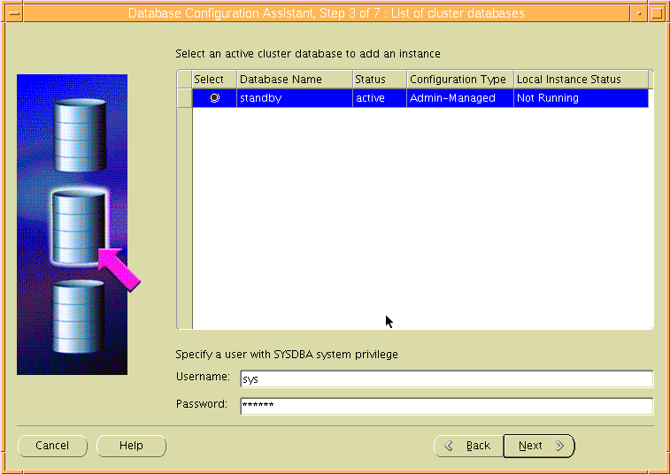
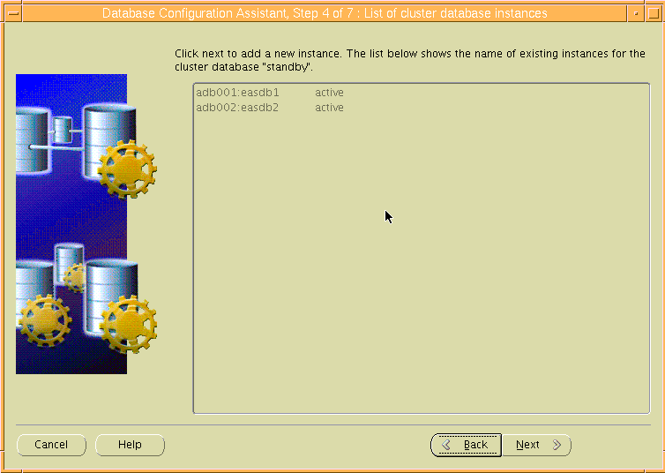
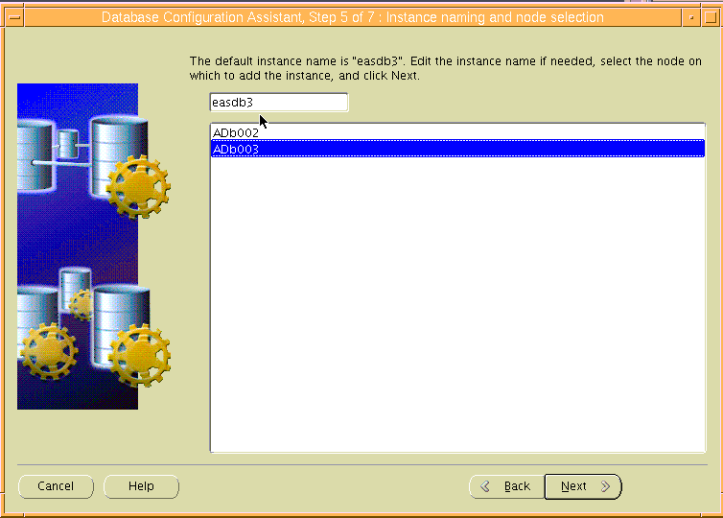
在这步中为easdb3添加undotbs3和redo日志组
Undotbs3添加4个数据文件：
+DATA0/easdb/datafile/undotbs031.dbf size 8192M
+DATA0/easdb/datafile/undotbs032.dbf size 8192M
+DATA0/easdb/datafile/undotbs033.dbf size 8192M
+DATA0/easdb/datafile/undotbs034.dbf size 8192M
Redo日志组：
+REDO/easdb/redo301.log 1GB
+REDO/easdb/redo302.log 1GB
+REDO/easdb/redo303.log 1GB
+REDO/easdb/redo304.log 1GB

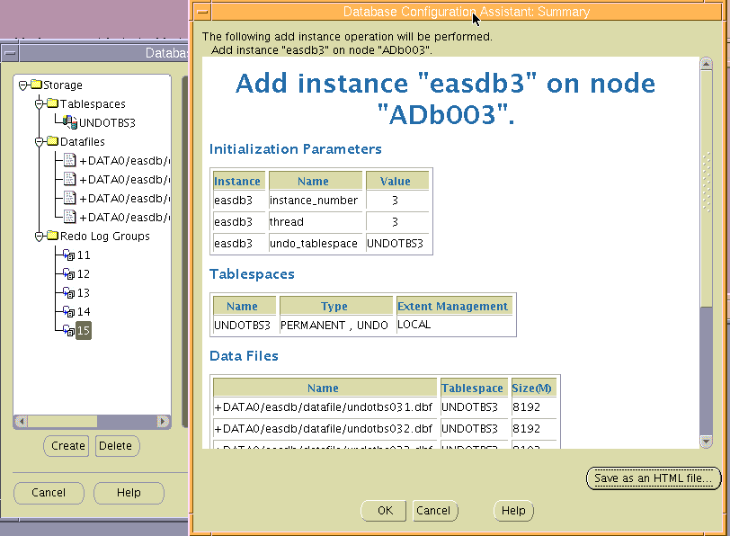
点击OK等待easdb3实例添加完成。

8.21修改easdb3参数
alter system set sga_max_size=64000M scope=spfile sid='easdb3';
alter system set sga_target=0 scope=spfile sid='easdb3';
alter system set memory_max_target=0 scope=spfile sid='easdb3';
alter system set memory_target=0 scope=spfile sid='easdb3';
alter system set db_cache_size=40064M scope=spfile sid='easdb3';
alter system set shared_pool_size=15104M scope=spfile sid='easdb3';
alter system set open_cursors=2000 scope=spfile sid='easdb3';
alter system set pga_aggregate_target=12000M scope=spfile sid='easdb3';
alter system set streams_pool_size=256M scope=spfile sid='easdb3';
alter system set large_pool_size=896M scope=spfile sid='easdb3';

create pfile='/home/oracle/pfile.ora' from spfile;
shutdown immediate
删除*.memory_max_size和*.memory_target（禁用AMM自动内存管理）
startup pfile='/home/oracle/pfile.ora' nomount;
create spfile='+DATA0/easdb/spfileeasdb.ora' from pfile='/home/oracle/pfile.ora';
shutdown immediate
startup

8.22删除eas2服务
srvctl stop service -d standby -s eas2 -i easdb2
srvctl remove service -d standby -s eas2 -i easdb2

8.23修改db_unique_name
alter system set db_unique_name='oradb' scope=spfile;
shutdown immediate
startup(三个节点均重启实例）

8.24添加oradb资源
srvctl add database -d oradb -o /u01/app/oracle/product/11.2.0/db_1

8.25删除standby资源所包含的实例
srvctl remove instance -d standby -i easdb1
srvctl remove instance -d standby -i easdb2
srvctl remove instance -d standby -i easdb3

8.26添加instance easdb1、easdb2到oradb资源
srvctl add instance -d oradb -i easdb1 -n ADb001
srvctl add instance -d oradb -i easdb2 -n ADb002
srvctl add instance -d oradb -i easdb3 -n ADb003

8.27添加服务
三个服务为oradb1、oradb2、oradb3，其中1服务备2号节点，2、3服务互备
srvctl add service -d oradb -s oradb1 -r easdb1 -a easdb2
srvctl add service -d oradb -s oradb2 -r easdb2 -a easdb3
srvctl add service -d oradb -s oradb3 -r easdb3 -a easdb2

srvctl enable service -d oradb -s oradb1 -i easdb1
srvctl enable service -d oradb -s oradb2 -i easdb2
srvctl enable service -d oradb -s oradb3 -i easdb3

srvctl start service -d oradb -s oradb1 -i easdb1
srvctl start service -d oradb -s oradb2 -i easdb2
srvctl start service -d oradb -s oradb3 -i easdb3

8.28集群状态
$ crs_stat -t -v
Name Type R/RA F/FT Target State Host
----------------------------------------------------------------------
ora.CRS.dg ora....up.type 0/5 0/ ONLINE ONLINE adb001
ora.DATA0.dg ora....up.type 0/5 0/ ONLINE ONLINE adb001
ora.DATA1.dg ora....up.type 0/5 0/ ONLINE ONLINE adb001
ora.DATA2.dg ora....up.type 0/5 0/ ONLINE ONLINE adb001
ora.FRA.dg ora....up.type 0/5 0/ ONLINE ONLINE adb001
ora....ER.lsnr ora....er.type 0/5 0/ ONLINE ONLINE adb001
ora....N1.lsnr ora....er.type 0/5 0/0 ONLINE ONLINE adb003
ora....N2.lsnr ora....er.type 0/5 0/0 ONLINE ONLINE adb001
ora....N3.lsnr ora....er.type 0/5 0/0 ONLINE ONLINE adb002
ora.REDO.dg ora....up.type 0/5 0/ ONLINE ONLINE adb001
ora....SM1.asm application 0/5 0/0 ONLINE ONLINE adb001
ora....01.lsnr application 0/5 0/0 ONLINE ONLINE adb001
ora.adb001.gsd application 0/5 0/0 OFFLINE OFFLINE
ora.adb001.ons application 0/3 0/0 ONLINE ONLINE adb001
ora.adb001.vip ora....t1.type 0/0 0/0 ONLINE ONLINE adb001
ora....SM2.asm application 0/5 0/0 ONLINE ONLINE adb002
ora....02.lsnr application 0/5 0/0 ONLINE ONLINE adb002
ora.adb002.gsd application 0/5 0/0 OFFLINE OFFLINE
ora.adb002.ons application 0/3 0/0 ONLINE ONLINE adb002
ora.adb002.vip ora....t1.type 0/0 0/0 ONLINE ONLINE adb002
ora....SM3.asm application 0/5 0/0 ONLINE ONLINE adb003
ora....03.lsnr application 0/5 0/0 ONLINE ONLINE adb003
ora.adb003.gsd application 0/5 0/0 OFFLINE OFFLINE
ora.adb003.ons application 0/3 0/0 ONLINE ONLINE adb003
ora.adb003.vip ora....t1.type 0/0 0/0 ONLINE ONLINE adb003
ora.asm ora.asm.type 0/5 0/ ONLINE ONLINE adb001
ora.cvu ora.cvu.type 0/5 0/0 ONLINE ONLINE adb002
ora.gsd ora.gsd.type 0/5 0/ OFFLINE OFFLINE
ora....network ora....rk.type 0/5 0/ ONLINE ONLINE adb001
ora.oc4j ora.oc4j.type 0/1 0/2 ONLINE ONLINE adb002
ora.ons ora.ons.type 0/3 0/ ONLINE ONLINE adb001
ora.oradb.db ora....se.type 0/2 0/1 ONLINE ONLINE adb001
ora....db1.svc ora....ce.type 0/0 0/0 ONLINE ONLINE adb001
ora....db2.svc ora....ce.type 0/0 0/0 ONLINE ONLINE adb002
ora....db3.svc ora....ce.type 0/0 1/0 ONLINE ONLINE adb003
ora....ry.acfs ora....fs.type 0/5 0/ ONLINE ONLINE adb001
ora.scan1.vip ora....ip.type 0/0 0/0 ONLINE ONLINE adb003
ora.scan2.vip ora....ip.type 0/0 0/0 ONLINE ONLINE adb001
ora.scan3.vip ora....ip.type 0/0 0/0 ONLINE ONLINE adb002

九、EM管理器创建
在p570节点创建EM
删除旧的EM配置：
$emca -deconfig dbcontrol db
Sql>drop user sysman cascade;
Sql>drop role MGMT_USER;
Sql>drop user MGMT_VIEW cascade
Sql>drop public synonym MGMT_TARGET_BLACKOUTS;
Sql>drop public synonym SETEMVIEWUSERCONTEXT
创建EM
$emca -config dbcontrol db -repos recreate -cluster
Enter the following information:
Database unique name: oradb
Service name: oradb1
Listener port number: 1521
Listener ORACLE_HOME [ /u01/app/11.2.0/grid ]: /u01/app/oracle/product/11.2.0/db_1
Password for SYS user:oracle
。
。
。
。

直至EM创建成功。
登陆https://10.10.20.201:5501/em监控oracle运行状态。
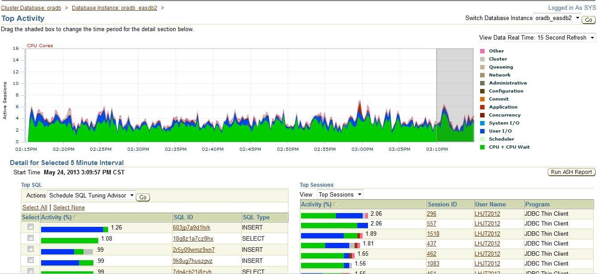

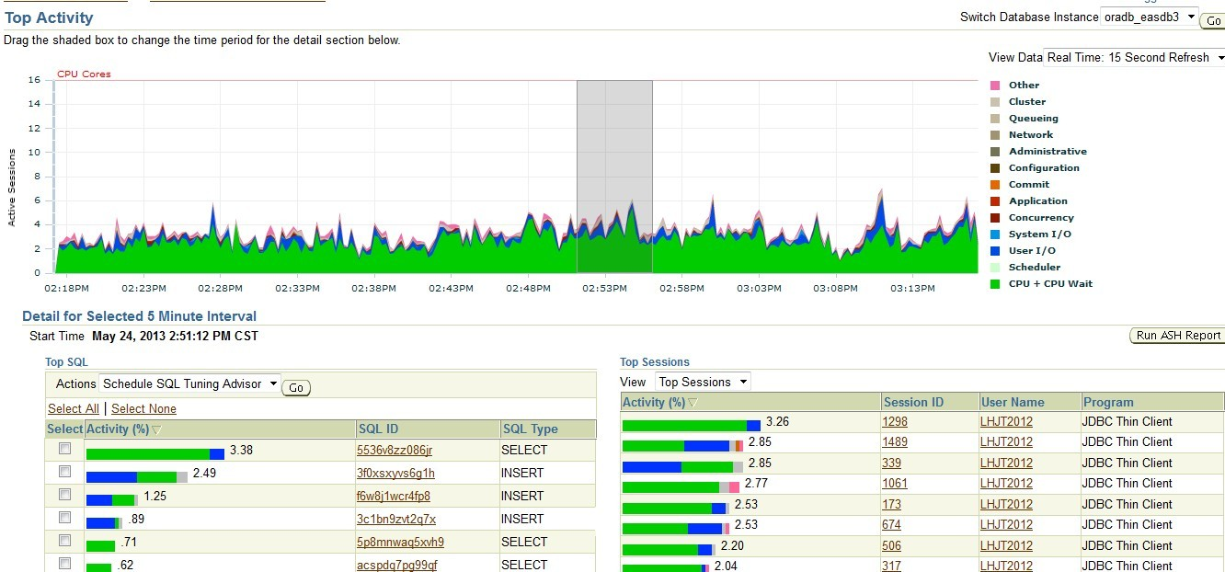
经过连续几天观察，业务状况较为稳定。整个迁移过程完成。

三、实施问题及解决办法

1、归档无法删除问题
实施完成后，进行NBU备份，查看备份日志可以看到如下信息：
archived log file name=+FRA/standby/archivelog/2013_05_17/thread_1_seq_8711.380.815644715 thread=1 sequence=8711
channel ch00: starting archived log backup set
channel ch00: specifying archived log(s) in backup set
input archived log thread=1 sequence=8713 RECID=127 STAMP=815693637
channel ch00: starting piece 1 at 22-MAY-13
channel ch01: finished piece 1 at 22-MAY-13
piece handle=al_92973_1_816101711 tag=TAG20130522T145506 comment=API Version 2.0,MMS Version 5.0.0.0
channel ch01: backup set complete, elapsed time: 00:00:25
channel ch01: deleting archived log(s)
RMAN-08137: WARNING: archived log not deleted, needed for standby or upstream capture process
archived log file name=+FRA/standby/archivelog/2013_05_17/thread_1_seq_8712.382.815644907 thread=1 sequence=8712
channel ch01: starting archived log backup set
channel ch01: specifying archived log(s) in backup set
input archived log thread=1 sequence=8714 RECID=130 STAMP=815696385
channel ch01: starting piece 1 at 22-MAY-13
channel ch02: finished piece 1 at 22-MAY-13
piece handle=al_92974_1_816101711 tag=TAG20130522T145506 comment=API Version 2.0,MMS Version 5.0.0.0
channel ch02: backup set complete, elapsed time: 00:00:25
channel ch02: deleting archived log(s)
RMAN-08137: WARNING: archived log not deleted, needed for standby or upstream capture process
archived log file name=+FRA/standby/archivelog/2013_05_17/thread_2_seq_19886.381.815644905 thread=2 sequence=19886
channel ch02: starting archived log backup set
channel ch02: specifying archived log(s) in backup set
input archived log thread=1 sequence=8715 RECID=132 STAMP=815696552
channel ch02: starting piece 1 at 22-MAY-13
channel ch03: finished piece 1 at 22-MAY-13
piece handle=al_92975_1_816101711 tag=TAG20130522T145506 comment=API Version 2.0,MMS Version 5.0.0.0
channel ch03: backup set complete, elapsed time: 00:00:25
channel ch03: deleting archived log(s)
RMAN-08137: WARNING: archived log not deleted, needed for standby or upstream capture process
提示归档无法删除，根据报错提示判断出和dataguard配置有关。于是清除现有的Dataguard配置：
show parameter LOG_ARCHIVE_CONFIG

NAME TYPE VALUE
------------------------------------ ---------------------- ------------------------------
log_archive_config string DG_CONFIG=(easdb,standby)
SQL> alter system set LOG_ARCHIVE_CONFIG='' scope=both;

System altered.

SQL> show parameter LOG_ARCHIVE_DEST_2

NAME TYPE VALUE
------------------------------------ ---------------------- ------------------------------
log_archive_dest_2 string SERVICE=easdb LGWR SYNC AFFIRM
VALID_FOR=(ONLINE_LOGFILES,PR
IMARY_ROLE) DB_UNIQUE_NAME=eas
db
SQL> alter system set LOG_ARCHIVE_DEST_2='' scope=both;

System altered.

SQL> show parameter fal_client

NAME TYPE VALUE
------------------------------------ ---------------------- ------------------------------
fal_client string STANDBY
SQL> alter system set fal_client='' scope=both;

System altered.

SQL> alter system set FAL_SERVER='' scope=both;

System altered.

SQL> show parameter FAL_SERVER

NAME TYPE VALUE
------------------------------------ ---------------------- ------------------------------
fal_server string
SQL> show parameter STANDBY_FILE_MANAGEMENT

NAME TYPE VALUE
------------------------------------ ---------------------- ------------------------------
standby_file_management string AUTO
之后进行rman备份，可以看到正常删除已备份的归档日志文件。+fra磁盘组空间释放。

2、清除DG配置后重启实例无法启动问题
清除DG配置后重启实例发生如下问题：
ALTER DATABASE OPEN
Picked broadcast on commit scheme to generate SCNs
WARNING: The 'LOG_ARCHIVE_CONFIG' init.ora parameter settings
are inconsistent with another started instance. This may be
caused by the 'DB_UNIQUE_NAME' init.ora parameter being specified
differently on one or more of the other RAC instances; the
DB_UNIQUE_NAME parameter value MUST be identical for all
instances of the database.
Errors in file /data/oracle/diag/rdbms/test/test1/trace/test1_lgwr_24686.trc:
ORA-16188: LOG_ARCHIVE_CONFIG settings inconsistent with previously started instance
Errors in file /data/oracle/diag/rdbms/test/test1/trace/test1_lgwr_24686.trc:
ORA-16188: LOG_ARCHIVE_CONFIG settings inconsistent with previously started instance
LGWR (ospid: 24686): terminating the instance due to error 16188

ORA-1092 : opitsk aborting process

System state dump is made for local instance
System State dumped to trace file /data/oracle/diag/rdbms/test/test1/trace/test1_diag_24652.trc
Trace dumping is performing id=[cdmp_20090424163154]

Instance terminated by LGWR, pid = 24686
重启整个数据库：
Srvctl stop database -d oradb
Srvctl start database -d oradb
继续报错：
PRCR-1079 : Failed to start resource ora.oradb.db
CRS-5017: The resource action "ora.oradb.db start" encountered the following error:
ORA-03113: end-of-file on communication channel
Process ID: 30539942
Session ID: 1009 Serial number: 1
. For details refer to "(:CLSN00107:)" in "/u01/app/11.2.0/grid/log/adb003/agent/crsd/oraagent_oracle/oraagent_oracle.log".

CRS-2674: Start of 'ora.oradb.db' on 'adb003' failed
CRS-2632: There are no more servers to try to place resource 'ora.oradb.db' on that would satisfy its placement policy
CRS-5017: The resource action "ora.oradb.db start" encountered the following error:
ORA-03113: end-of-file on communication channel
Process ID: 7864602
Session ID: 1009 Serial number: 1
. For details refer to "(:CLSN00107:)" in "/u01/app/11.2.0/grid/log/adb002/agent/crsd/oraagent_oracle/oraagent_oracle.log".

CRS-2674: Start of 'ora.oradb.db' on 'adb002' failed
CRS-5017: The resource action "ora.oradb.db start" encountered the following error:
ORA-03113: end-of-file on communication channel
Process ID: 3933112
Session ID: 195 Serial number: 3
. For details refer to "(:CLSN00107:)" in "/u01/app/11.2.0/grid/log/adb001/agent/crsd/oraagent_oracle/oraagent_oracle.log".
整个库启动无法启动，尝试单个实例启动：
Easdb2:
Sql>startup nomount;
Sql>alter database mount;
Database altered
Sql>alter database open;
报错如下：
LGWR: Primary database is in MAXIMUM AVAILABILITY mode
LGWR: Destination LOG_ARCHIVE_DEST_1 is not serviced by LGWR
LGWR: Minimum of 1 LGWR standby database required
Errors in file /u01/app/oracle/diag/rdbms/oradb/easdb2/trace/easdb2_lgwr_10420430.trc:
ORA-16072: a minimum of one standby database destination is required
LGWR (ospid: 10420430): terminating the instance due to error 16072
Sat May 25 23:49:42 2013
System state dump requested by (instance=2, osid=10420430 (LGWR)), summary=[abnormal instance termination].
System State dumped to trace file /u01/app/oracle/diag/rdbms/oradb/easdb2/trace/easdb2_diag_30408808.trc
Sat May 25 23:49:43 2013
ORA-1092 : opitsk aborting process
Sat May 25 23:49:43 2013
License high water mark = 2
Dumping diagnostic data in directory=[cdmp_20130525234942], requested by (instance=2, osid=10420430 (LGWR)), summary=[abnormal instance termination].
Sat May 25 23:49:44 2013
Instance terminated by LGWR, pid = 10420430
USER (ospid: 3342424): terminating the instance
Instance terminated by USER, pid = 3342424
根据错误提示判断出LGWR进程有问题，还是和dataguard 配置有关：

重新启动实例至mount状态将备库模式设置为最大性能：
SQL> startup mount;
ORACLE instance started.
Total System Global Area 2147483648 bytes
Fixed Size 1220460 bytes
Variable Size 452984980 bytes
Database Buffers 1677721600 bytes
Redo Buffers 15556608 bytes
Database mounted.
SQL> alter database set standby database to maximize performance;

Database altered.

SQL> alter database open;

Database altered.
成功打开数据库。之后重新创建spfile，数据库可以正常关闭启动。
Sql>create spfile=’+DATA0/easdb/spfileoradb.ora’ from pfile=’/home/oracle/pfile.ora’;
Filed created
Sql>shutdown immediate
Sql>startup

四、项目总结
新希望六和集团机房搬迁项目实施过程：

项目 | 时间 | 工作内容 | 实施人员 | 结果
第一阶段 | 2013年3月25日 | 商讨搬迁方案及存储划分方案。 | 蔡伟 | 确定实施方案
第二阶段 | 2013年4月15日—25日 | 1、单节点rac安装2、单节点rac打PSU 3、rman恢复搭建测试库  4、进行应用测试 | 蔡伟 | 完成oracle11203单节点rac的搭建并升级PSU，并在该单节点rac上成功搭建测试系统。之后进行业务压力详细测试
第三阶段 | 2013年5月15日—5月24日 | 1、主库rac to备端单节点rac dataguard搭建  2、拆除主端rac2号节点添加至备端，此时备端形成2节点rac  3、主备切换，新的rac备端切换为主端，原主端切换为备端  4、观察两天业务后，将原主端（现备端）的另一台P740拆除并添加至新rac集群环境形成3节点rac | 蔡伟  刘跃光 | 原主端rac环境在很短的停机条件下成功迁移至电信机房，并重新投入生产运行。
第五阶段 | 2013年5月25日—30日 | 监控新rac集群运行状态 | 蔡伟 | 经过多日监控，新的集群环境运行较为稳定。

至此，新希望六和集团机房搬迁数（据库部分）项目顺利完成，生产系统上线工作正常，达到预期目标。

